|  |  |
| --- | --- |
| Harrow Council Logo | |
| REPORT FOR: | **Governance**, **Audit** and Risk Management Committee. | |
| Date of Meeting: | 16 July 2019 | |
| Subject: | Annual Health and Safety Report | |
| Responsible Officer: | Paul Walker, Corporate Director (Community) | |
| Exempt: | No | |
| Wards affected: | N/A | |
| Enclosures: | Appendix 1 – Analysis Report for Accidents and Incidents Quarter 1 To Quarter 4 (1st April 2018 – 31st March 2019)  Appendix 2 – Trends  Appendix 3 – H&S Strategy 2019-2022  Appendix 4 – Corporate H&S Board Terms of Reference  Appendix 5 – Occupational Health Overview 2018-19  Appendix 6 – Health & Safety Policy 2019-2020 | |

|  |
| --- |
| Section 1 – Summary and Recommendations |
| This report summarises the council’s health and safety performance for the year 1st April 2018 to 31st March 2019, providing an update of activities and giving information on outcome measures – training, audits and accidents. Information about Occupational Health is provided for information as does not sit within the Corporate Health & Safety remit. The report also seeks to approve the Health & Safety Strategy and Policy Recommendations: The Committee is requested to:   1. Note the Accidents and Incidents report for information 2. Approve the Health & Safety Strategy as set out in Appendix 3 3. Approve the annual Health & Safety Policy in Appendix 6 |

# Section 2 – Report

**Executive Summary**

* 1. The Corporate Health and Safety Service has continued to develop the health and safety management system and to provide support and guidance across the organisation during the period from April 2018 to March 2019.
  2. Part of this has included the establishment of safety circles across the directorates, as well as directorate health and safety management teams, to provide the hierarchy from the Corporate Health and Safety Board to the front line staff..
  3. The key work streams during the period have been:
* The introduction of an Health & Safety Strategy and Action Plan (see **Appendix 3**).
* The annual review of the Health & Safety Policy (see **Appendix 6**)
* Maintenance and introduction of organisation specific health and safety policies and Codes of Practice.
* Provision of health and safety support, advice and guidance.
* Continued delivery of health and safety training.
  1. The management of the occupational health service and employee assistance programme has stayed with HR, due to direct links with employment and sickness.
  2. The key points from the period April 2018 - March 2019are as follows:
* No enforcement action from the HSE.
* There has been significant increase in incident reporting (1349 recorded in 2018/19, 722 recorded 17/18). This increase has occured in the main within schools (73% of all incidents reported), where a lot of work has taken place by Corporate Health & Safety to ensure that incidents are logged on to the SHE software, being the corporate software system that is used for monitoring and recording health and safety across the organisation.
* There has however been a drop in the number of RIDDOR reportable incidents (22 reported in 2018/19, compared with 27 reportable incidents in 2017/18).

## Background

## 2.6 An annual safety review is undertaken and a report prepared detailing health and safety performance to enable the Council to determine it’s effectiveness in managing risk and address any shortcomings.

## 

## External Assurance

2.7 In 2016 an audit was conducted by Croner, leading to a full review of all aspects of Corporate Health & Safety including the governance, resulting in an initial action plan that was taken to Corporate Strategic Board in 2017 and GARMSC in 2018.

## Improvement Plan

2.8 Following the completion of the Croner audit in January to March 2016, work to set out actions required, and approval by Corporate Strategic Board in September 2017 and Governance, Audit and Risk Management Committee (GARMSC) in October 2017, a strategy document was produced setting out the aims and objectives of the corporate health & safety service

2.9 In February 2019, a temporary Health & Safety Compliance Manager was employed who has reviewed and rewritten the health and safety strategy and accompanying action plan. This can be found in **Appendix 3**

2.10 The action plan is underway and monitored by the Corporate Health & Safety Board that meets on a current quarterly basis to ensure implementation. Focus is on ensuring all are aware of their responsibilities and governance is in place.

2.11 As part of this, and in line with legislative requirements, the Health & Safety Policy for the Council has been refreshed and updated, and is included in **Appendix 6**

## Health and Safety Policy and Guidance

* 1. A review of all existing policies and codes of practice was undertaken in this year, including the overarching health and safety policy which has been signed off by the Council Leader and Chief Executive. Updates were made to reflect changes in organisational structure, as well as a new smoking policy which combines the separate HR document with the Health and Safety document.

## Health and Safety Groups

* 1. Due to internal changes, this aspect is being sought to be revitalised to ensure that it happens, due to past concerns over poor representation from all directorates.
  2. Revitalisation has taken place in the Community directorate with greater focus on service involvement.
  3. In addition a Depot Health at Work group meets monthly at present to reflect the high risk nature of activities at the depot, and the chairing of this has passed to Facilities Management as the Corporate Landlord.

## Health and Safety Visits, Inspections and Audits

2.16 Site visits, inspections and accident investigations have continued to be performed by the Corporate Health and Safety Service through the organisation.

2.17 Further e-self health and safety audits are to be conducted both by managers and by corporate health and safety team, within the year to establish the current level of health & safety compliance throughout the organisation, especially following a number of directorates restructures that have, and currently being, undertaken.

* 1. The service has also continued to respond to requests for site visits, principally in schools, providing guidance and support on a range of issues including monitoring the summer holiday building works programme and fire arrangements.
  2. Going forward, a plan of site audits will be taking place using the capacity within the Corporate Health & Safety Team to ensure health & safety stays at the forefront of the organisation and schools. Part of this is management self-audits across the organisation.

## Education Outside the Classroom

2. 20 The service has continued to review assessments for a wide range of trips including residential trips, outdoor activities and overseas trips.

## Occupational Health

* 1. HML continues to provide the occupational health service and the service is overseen by HR. They continue to carry out online and face to face appointments, the latter being held off-site at a number of their premises. As a result they are able to breakdown use by Council Staff and Schools.
  2. **Appendix 5** provides a breakdown of Occupational Health referrals for the period 2018-19 for information
  3. HM Assist has continued to provide an Employee Assistance Programme to the organisation whereby employees can freely obtain a range of services including specialist counselling and financial advice. This service has continued to be promoted throughout the year.

## Promotion of Health, Safety and Well Being

## 

2.24 Public Health, under the People Directorate, leads on implementation of the London Healthy Workplace Charter in Harrow.

2.25 There is also the Health & Wellbeing Board (HWBB) which is a multi-agency group focused on improving the health of residents in Harrow. The group is made up of:

* the council
* NHS commissioners
* GP commissioners
* the voluntary sector together to focus on.

2.26 The HWBB is chaired by the Leader of Harrow Council. It is the executive body responsible for agreeing what the needs of the local population are, promoting integration and supporting alignment and joint commissioning.

#### Incidents reported

2.27 Incident performance is still monitored by both the directorate & corporate groups every quarter. The data is considered both in terms of volume and through key performance indicators which allow consideration of the number of employees and number of employee hours worked.

2.28 There have been 666 employee related incidents (this includes all near misses, and not just accidents) in this period, 13 of which have required reporting to the Health and Safety Executive.

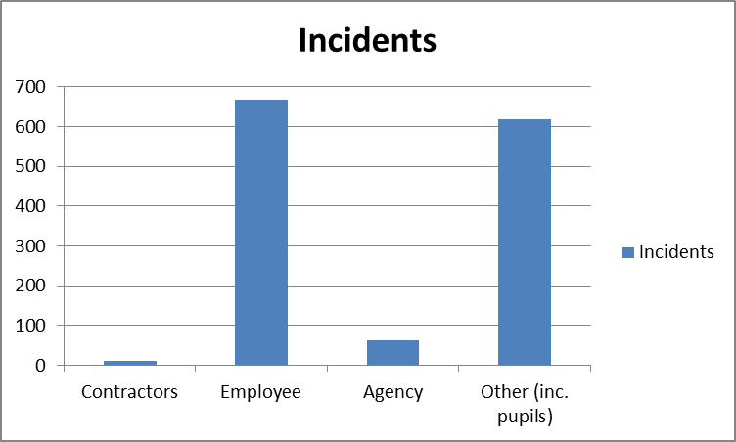

2.29 This year the largest accident types across the corporate estate, including schools which have signed up to the Service Level Agreement with Corporate Health & Safety, were Challenging Behaviour (413), Slips, Trips and Falls, (187) and Physical Assaults (182). The vast majority of these occurred at schools:

2.30 Within these top 3 categories, 5 were RIDDOR reportable and are broken down in **Appendix 2**

2.31 A breakdown of incidents in schools with an SLA with the Council has highlighted that schools where work by Corporate Health & Safety has led to all incidents recorded, as previously only high risk ones were. Of all these incidents, a high proportion are minor and near misses. This should be not be interpreted as a failure of the schools, but a natural increase in numbers associated with better education and understanding. This is in line with the report to GARMSC in 2018 where it was reported that a measure of success of the Corporate Health and Safety was an increase in reporting in the next few years.

2.32 This work, as well as the increase in incidences, has highlighted some other schools incident numbers remain low and work is to take place to understand if all incidents are being reported.

2.33 Of the 366 incidents not related to schools, 74% relate to the Community Directorate that includes Special Needs Transport. This is reflected in that 32.4% of all incidents relate to challenging behaviour (51.7% of those related to children/adults transported). Overall though, the downward trend in incidents in Community continues (6% drop in last 2 years)

2.34 Of the other directorates / areas, People Directorate accounted for 21.5% of the 366 incidents, Resources and Commercial accounted for 5%. Regeneration and Planning Service were the only service reporting no incidents in 2018-19

2.35 Two key performance indicators (see **Appendix 2**) are used to monitor performance, the accident incidence rate, which is the number of accidents per 100,000 employees and the reportable injury frequency rate, which is the number of incidents reportable to the HSE per 100,000 person hours.

2.36 A review of the accident incident rate over the last four years has revealed that there have been steady rises, which correlates with increased reporting from schools

2.37 The RIDDOR injury frequency rate over the last four years has seen an initial increase followed by a reduction.

2.38 The service continues to record incidents relating to non-employees where it relates to the organisation’s activities or the use of its facilities. Nearly all these incidents relate to pupils and are minor incidents e.g. sports or playground injuries. There are no trends identified from this data and individual incidents have been addressed in the appropriate manner.

2.39 Analysis of the trends from the key performance indicators and the incident type and occupation indicates that overall incident performance within the Council is improving. The health and safety audit programme has focussed on areas where management of risk will reduce the potential for an incident, for example, lone working assessments for social care workers and managing medicines arrangements in schools.

2.40 Continuous improvement in risk assessment and safety procedures will improve incident performance but due to the low numbers and the diverse nature of the incidents, the improved performance cannot be attributed to direct intervention in key areas.

2.41 Work has also taken place with the waste service and streets and grounds, to address matters such as PPE

## Health and Safety Training Data

2.41 A training programme has continued to be delivered by the Corporate Health and Safety Service, but within the bigger remit of the Training Academy since 2017

2.42 The Commercial Safety Team has worked with the Training Academy to ensure it is an accredited training centre for Highfield and Chartered Institute of Environmental Health (CIEH); offering accredited and bespoke courses across all areas of health & safety, food safety and public health matters.

2.43 These courses are available on the training calendar and the service will continue to monitor incident performance, using the improved SHEAssure software arrangements, against delivered training to identify positive impacts and areas where further training is necessary.

2.44 It has been noted that not all new starters are attending the induction training with the course now available online through learning pool, which should aid greater completion of the course.

2.45 Work is taking place with the Learning and Development Team to improve the induction training as well as the mandatory on line health & safety training course.

## Legislation Update

2.46 The period 2018/19 saw no significant legislation change that impacted the reporting of health & safety.

## Stakeholder Feedback

## 2.47 The Corporate Health & Safety Board, chaired by the Corporate Director Community, includes both recognised Trade Unions, who continue to be proactive in their approach to health & safety. The terms of reference for this is shown in Appendix 4

## 2.48 There has been no enforcement activity by the HSE during this period.

## 

**Management Assurance**

2.49 Monitoring of health and safety performance within the organisation will continue to sit with the Corporate Health & Safety Board going forward, who will provide updates to the Corporate Strategic Board

2.50 Due to the restructures over the last 6 months, and changes around the Council, the Directorate health and safety forums are to be re-energised to ensure taking place regularly and effectively. Presentations to the Directorate Meetings took place throughout 2018-19

2.51 Presentations around performance, strategy and policy have taken place on a regular basis to the Corporate Strategic Board, and are reported on at the Corporate Board.

## Plans for April 2019 - March 2020

2.53 The key actions for 2019/20 include the following:

* Continuation of safety teams across the Council, in line with the Health & Safety Strategy
* Corporate take up of the Assure SHE Software as the recognised software system for all health and safety matters including reporting of incidents, targeting areas where low numbers reported
* Health and safety support and advice within Harrow Council.
* Training programme across the Council to ensure all receive the necessary training, with British Safety Council training for Directors and Heads of Service taking place
* Implementation of the Health and Safety Strategy

## Legal Implications

The Health and Safety at Work etc Act 1974 requires employers to ensure, so far as is reasonably practicable, the health, safety and welfare at work of all his employees, and also to prepare (and review) a policy in relation to it.

## Financial Implications

Health and safety management is integral to directorate budgets, and the functions of the Corporate Health and Safety team are carried out within the budget available.

A one-off corporate funding was  secured in 2018/19 to bring in additional capacity to ensure the successful implementation of the health & safety strategy. The works continue in 2019/20 and the costs are to be met from the unspent funding carried forward from 2018/19

## Risk Management Implications

Health and Safety is on the Directorate and Corporate Risk Register

The risk identified is “Failure to fulfil the Council’s Health & Safety duties leading to a harmful event for an individual/individuals for which the Council is responsible leading to litigation”. As a result, a risk register has been prepared by the Temporary Health & Safety Compliance Manager to ensure key high risk areas are addressed while the strategy is implemented.

## Equalities implications / Public Sector Equality Duty

This report is for information, and protected characteristics are constantly measured as part of any health & safety system, especially aspects of age and disability.

## Council Priorities

The delivery of health and safety management is integral to, and supports the achievement of all Corporate Priorities.

# Section 3 - Statutory Officer Clearance

|  |  |  |  |
| --- | --- | --- | --- |
|  |  |  | on behalf of the |
| Name: Jessie Man | X |  | Chief Financial Officer |
| Date: 24 June 2019 |  |  |  |
|  |  |  | on behalf of the |
| Name: Paresh Mehta | X |  | Monitoring Officer |
| Date: 8 July 2019 |  |  |  |

|  |  |  |  |
| --- | --- | --- | --- |
|  |  |  |  |
| Name: Paul Walker | X |  | Corporate Director |
| Date: 8 July 2019 |  |  |  |

|  |  |
| --- | --- |
| Ward Councillors notified: | **NO** |

# Section 4 - Contact Details and Background Papers

Contact: Richard Le-Brun, Head of Community & Public Protection, 020 8736 6267

**Background Papers:** Corporate Health & Safety Action Plan

**APPENDIX 1**

Specific details regarding RIDDORs is available, but are reviewed as standard practice.

Harrow as a whole – Employees Q1 to Q4 2018/19

|  |  |  |  |  |  |  |  |  |
| --- | --- | --- | --- | --- | --- | --- | --- | --- |
|  | **Total Incidents recorded for the last 3 years** | | | **Breakdown of 2018-2019 data by occupation** | | | | |
| **Type of Incident** | **2018-2019** | **2016-2017** | **2017-2018** | **Trend** | **Contractor(s)** | **Employee** | **Employee - Agency** | **Other** |
| Challenging Behaviour | **413** | 61 | 87 | 🡹 |  | 244 | 30 | 139 |
| Slipped, Tripped Or Fell On The Same Level | **187** | 29 | 22 | 🡹 |  | 41 | 5 | 141 |
| Physically Assaulted By A Person | **182** | 18 | 16 | 🡹 | 3 | 129 | 4 | 46 |
| Aggression and Violent Behaviour | **121** | 15 | 11 | 🡹 |  | 92 | 3 | 26 |
| Near Miss | **66** | 8 | 7 | 🡹 | 2 | 38 | 2 | 24 |
| Hit By A Moving, Flying Or Falling Object | **46** | 7 | 3 | 🡹 |  | 21 | 3 | 22 |
| Hit Something Fixed Or Stationary | **41** | 3 | 1 | 🡹 | 1 | 11 |  | 29 |
| Physical Contact (Not Assault) | **41** | 1 | 2 | 🡹 |  | 14 |  | 27 |
| Fell From A Height (State Height in Notes) | **34** | 4 | 8 | 🡹 | 1 | 8 |  | 25 |
| Medical Emergency | **20** | 13 | 18 | 🡹 |  | 5 |  | 15 |
| Sports Injury | **20** |  |  | 🡹 |  |  |  | 20 |
| Contact With Sharp Object | **15** | 3 |  | 🡹 |  | 4 | 4 | 7 |
| Feeling faint / Unconsciousness | **15** | 9 | 7 | 🡹 | 2 | 7 |  | 6 |
| Seizure | **14** | 26 | 13 | 🡹 |  |  |  | 14 |
| Incident Involving a Vehicle | **13** | 5 | 6 | 🡹 |  | 5 | 4 | 4 |
| Injured While Handling, Lifting Or Carrying | **13** | 20 | 8 | 🡹 |  | 11 |  | 2 |
| Safeguarding Incident | **12** | 9 | 15 | 🡻 |  | 1 |  | 11 |
| Faulty Apparatus | **9** | 4 | 2 | 🡹 |  | 5 | 1 | 3 |
| Trapped | **9** |  | 2 | 🡹 |  | 3 | 1 | 5 |
| Physical injury from an unknown origin | **8** | 3 | 4 | 🡹 |  | 1 |  | 7 |
| Burns | **7** | 5 | 1 | 🡹 | 1 | 3 | 1 | 2 |
| Incident With Verbal Abuse | **6** | 1 | 3 | 🡹 |  | 2 |  | 4 |
| Choking / Asphyxiation | **5** | 1 |  | 🡹 |  |  |  | 5 |
| Property Damage | **5** |  | 3 | 🡹 |  | 1 | 2 | 2 |
| Self-harm | **5** | 1 | 1 | 🡹 |  |  |  | 5 |
| Hit By A Moving Vehicle | **4** | 4 | 5 | 🡻 |  | 3 |  | 1 |
| Allergic Reaction/Anaphylaxis | **3** |  |  | 🡹 |  | 1 |  | 2 |
| Foreign Object in Eye | **3** | 1 |  | 🡹 |  | 2 | 1 | 0 |
| Incident With Burglary/Theft/Mugging | **3** | 1 | 2 | 🡹 |  |  |  | 3 |
| Incident With Faulty Equipment | **3** | 3 | 1 | 🡹 |  |  | 1 | 2 |
| Incident With Threatening Behaviour | **3** | 1 | 3 | ⬄ |  | 2 |  | 1 |
| Ingestion of Foreign Object | **3** |  |  | 🡹 |  |  |  | 3 |
| Fire Alarm Activated (non emergency) | **2** | 11 | 2 | ⬄ |  | 1 |  | 1 |
| Incident With Accidental Property Damage | **2** |  |  | 🡹 |  | 1 |  | 1 |
| Indecent Exposure (removal of clothing) | **2** |  |  | 🡹 |  |  |  | 2 |
| Injured By An Insect or Animal | **2** |  | 2 | ⬄ |  | 2 |  | 0 |
| Security Breach | **2** | 3 |  | 🡹 |  |  |  | 2 |
| Trapped By Something Collapsing or Overturning | **2** |  | 1 | 🡹 |  | 1 |  | 1 |
| Travel Sickness | **2** |  | 4 | 🡻 |  |  |  | 2 |
| Bin Falling off Refuse Truck | **1** | 2 |  | 🡹 |  |  |  | 1 |
| Contact With Electricity Or An Electrical Discharge | **1** |  |  | 🡹 |  | 1 |  | 0 |
| Contact With Moving Machinery Or Material Being Machined | **1** | 2 | 2 | 🡻 |  |  |  | 1 |
| Dangerous Occurrence | **1** | 1 | 4 | 🡻 |  |  |  | 1 |
| Exposure to excessive heat or cold | **1** | 1 |  | 🡹 |  |  |  | 1 |
| Exposure To Harmful Gases Or Vapours | **1** |  |  | 🡹 |  | 1 |  | 0 |
| Exposure To, Or In Contact With, A Harmful Substance | **1** | 1 | 1 | ⬄ |  | 1 |  | 0 |
| Fatality | **1** | 1 | 1 | ⬄ |  |  |  | 1 |
| Nosebleed | **1** |  | 2 | 🡻 |  | 1 |  | 0 |
| Not Specified | **1** |  |  | 🡹 |  | 1 |  | 0 |
| pain in her shoulders and breathless | **1** |  |  | 🡹 |  |  |  | 1 |
| Stress | **1** |  |  | 🡹 |  | 1 |  | 0 |
| Work Related Illness | **1** | 1 |  | 🡹 |  | 1 |  | 0 |
| Electrical Fault |  |  | 1 | 🡻 |  |  |  |  |
| Exposure To Fire |  | 1 |  | ⬄ |  |  |  |  |
| Incident with Vandalism |  |  | 1 | 🡻 |  |  |  |  |
| Smoke/Smoke Inhalation |  | 6 |  | ⬄ |  |  |  |  |
| Total | **1356** | 286 | 272 |  | 10 | 666 | 62 | 618 |

There has been a big jump in the number of incidents recorded. This is due to greater training on what requires reporting. The top 3 incident types are Challenging Behaviour (413) Slips, Trips and Falls (187); and Physical Assaults (182);

Other includes: Members of the public, service users, visitors, clients, young people volunteers etc.

There were 14 employee RIDDOR incidents and these are illustrated in the table below. The fatal incident, involved a member of the public that passed away in a sheltered housing unit. This was reported to CQC rather than RIDDOR

|  |  |  |  |  |  |  |
| --- | --- | --- | --- | --- | --- | --- |
| **Type of Incident** | **Directorate(s)** | **Notes** | **Total Incidents** |  | **Employee** | **Employee - Agency** |
| Aggression and Violent Behaviour | Community | Staff member injured by an aggressive member of the public in the civic building | **1** |  | 1 |  |
| Challenging Behaviour | Schools | Staff member was pushed by a young person who was in a state of high anxiety, and fell to the floor | **1** |  | 1 |  |
| Hit By A Moving, Flying Or Falling Object | Community | Staff member was struck by a bin that came off the refuse vehicle. | **1** |  | 1 |  |
| Incident Involving a Vehicle | Community (4) | 1. Staff was pushed onto the dashboard of the vehicle as they were exiting, when another vehicle struck the refuse vehicle from behind. 2. Staff slipped when entering the refuse vehicle as the ground was wet. 3. Staff lost control of vehicle due to a medical emergency, when driving around the borough. 4. Staff trapped fingers in the closing side door of a vehicle | **4** |  | 3 | 1 |
| Injured While Handling, Lifting Or Carrying | Schools (1), Community (2) | 1. Staff injured whilst undertaking grounds maintenance duties 2. Staff injured whilst completing personal care for a pupil in a school. 3. Staff was injured by lifting refuse bags. The bags were not labelled and contained heavy materials | **3** |  | 3 |  |
| Slipped, Tripped Or Fell On The Same Level | Community (2), People (1) | 1. Staff was pushed to the ground when a student fell on her. 2. Staff twisted foot as they walked out of a storage container 3. Staff fell down after stepping of a curb between two vehicles | **3** |  | 3 |  |
| Trapped | Community | Staff trapped their fingers in the tail lift when loading items onto it. | **1** |  | 1 |  |
| **Total** |  |  | **14** |  | **13** | **1** |

Community– Employees Q1 to Q4 2017/18

|  |  |  |  |  |  |  |  |  |
| --- | --- | --- | --- | --- | --- | --- | --- | --- |
|  | **Total Incidents recorded for the last 3 years** | | |  | **Breakdown of 2017-2018 data by occupation** | | | |
| **Type of Incident** | **2018-2019** | **2016-2017** | **2017-2018** | **Trend** | **Contractor(s)** | **Employee** | **Employee - Agency** | **Other** |
| Challenging Behaviour | 87 | 61 | 87 | 🡹 |  | 19 | 23 | 45 |
| Slipped, Tripped Or Fell On The Same Level | 44 | 29 | 22 | 🡹 |  | 15 | 5 | 24 |
| Medical Emergency | 11 | 13 | 18 | 🡻 |  | 2 |  | 9 |
| Incident Involving a Vehicle | 10 | 5 | 6 | 🡹 |  | 4 | 4 | 2 |
| Near Miss | 9 | 8 | 7 | 🡹 | 2 | 1 | 2 | 4 |
| Physically Assaulted By A Person | 9 | 18 | 16 | 🡻 | 3 | 2 |  | 4 |
| Aggression and Violent Behaviour | 7 | 15 | 11 | 🡻 |  | 5 |  | 2 |
| Contact With Sharp Object | 7 | 3 |  | 🡹 |  | 3 | 3 | 1 |
| Feeling faint / Unconsciousness | 7 | 9 | 7 | ⬄ | 1 | 3 |  | 3 |
| Faulty Apparatus | 6 | 4 | 2 | 🡹 |  | 2 | 1 | 3 |
| Hit Something Fixed Or Stationary | 6 | 3 | 1 | 🡹 |  | 5 |  | 1 |
| Fell From A Height (State Height in Notes) | 5 | 4 | 8 | 🡻 | 1 | 2 |  | 2 |
| Safeguarding Incident | 5 | 9 | 15 | 🡻 |  |  |  | 5 |
| Incident With Verbal Abuse | 4 | 1 | 3 | 🡹 |  | 1 |  | 3 |
| Injured While Handling, Lifting Or Carrying | 4 | 20 | 8 | 🡻 |  | 4 |  | 0 |
| Seizure | 4 | 26 | 13 | 🡻 |  |  |  | 4 |
| Trapped | 4 |  | 2 | 🡹 |  | 3 | 1 | 0 |
| Foreign Object in Eye | 3 | 1 |  | 🡹 |  | 2 | 1 | 0 |
| Hit By A Moving, Flying Or Falling Object | 3 | 7 | 3 | ⬄ |  | 3 |  | 0 |
| Incident With Burglary/Theft/Mugging | 3 | 1 | 2 | 🡹 |  |  |  | 3 |
| Incident With Faulty Equipment | 3 | 3 | 1 | 🡹 |  |  | 1 | 2 |
| Property Damage | 3 |  | 3 | ⬄ |  |  | 2 | 1 |
| Burns | 2 | 5 | 1 | 🡹 |  | 1 | 1 | 0 |
| Fire Alarm Activated (non emergency) | 2 | 11 | 2 | ⬄ |  | 1 |  | 1 |
| Hit By A Moving Vehicle | 2 | 4 | 5 | 🡻 |  | 2 |  | 0 |
| Incident With Accidental Property Damage | 2 |  |  | 🡹 |  | 1 |  | 1 |
| Incident With Threatening Behaviour | 2 | 1 | 3 | 🡻 |  | 1 |  | 1 |
| Nosebleed | 2 |  | 2 | ⬄ |  | 1 |  | 1 |
| Security Breach | 2 | 3 |  | 🡹 |  |  |  | 2 |
| Self-harm | 2 | 1 | 1 | 🡹 |  |  |  | 2 |
| Travel Sickness | 2 |  | 4 | 🡻 |  |  |  | 2 |
| Bin Falling off Refuse Truck | 1 | 2 |  | 🡹 |  |  |  | 1 |
| Dangerous Occurrence | 1 | 1 | 4 | 🡻 |  |  |  | 1 |
| Exposure To, Or In Contact With, A Harmful Substance | 1 | 1 | 1 | ⬄ |  | 1 |  | 0 |
| Fatality | 1 | 1 | 1 | ⬄ |  |  |  | 1 |
| Ingestion of Foreign Object | 1 |  |  | 🡹 |  |  |  | 1 |
| Injured By An Insect or Animal | 1 |  | 2 | 🡻 |  | 1 |  | 0 |
| Choking / Asphyxiation |  | 1 |  | ⬄ |  |  |  |  |
| Contact With Moving Machinery Or Material Being machined |  | 2 | 2 | 🡻 |  |  |  |  |
| Electrical Fault |  |  | 1 | 🡻 |  |  |  |  |
| Exposure to excessive heat or cold |  | 1 |  | ⬄ |  |  |  |  |
| Exposure To Fire |  | 1 |  | ⬄ |  |  |  |  |
| Incident with Vandalism |  |  | 1 | 🡻 |  |  |  |  |
| Physical Contact (Not Assault) |  | 1 | 2 | 🡻 |  |  |  |  |
| Physical injury from an unknown origin |  | 3 | 4 | 🡻 |  |  |  |  |
| Trapped By Something Collapsing or Overturning |  |  | 1 | 🡻 |  |  |  |  |
| Work Related Illness |  | 1 |  | ⬄ |  |  |  |  |
| **Totals** | **268** | **280** | **272** |  | **7** | **85** | **44** | **132** |

The number of incidents in this directorate has dropped very slightly (2017-2018 = 272, compared with 2018-2019 = 268). Challenging behaviour (87), Slips trips and falls (44) and Medical emergencies (11) have remained the top 3 incident types. This is in line with the data from last year.

People – Employees Q1 to Q4 2017/18

|  |  |  |  |  |  |  |  |
| --- | --- | --- | --- | --- | --- | --- | --- |
|  | Total incidents recorded for the last 3 years | | |  | Breakdown of 2018-2019 data | | |
| Type of Incident | 2018-2019 | 2016-2017 | 2017-2018 | Trend | Employee | Employee - Agency | Other |
| Challenging Behaviour | 20 | 4 | 4 | 🡹 | 9 | 3 | 8 |
| Slipped, Tripped Or Fell On The Same Level | 16 | 10 | 7 | 🡹 | 2 |  | 14 |
| Aggression and Violent Behaviour | 10 | 7 | 21 | 🡻 | 4 |  | 6 |
| Physically Assaulted By A Person | 6 | 5 | 6 | ⬄ | 1 |  | 5 |
| Hit Something Fixed Or Stationary | 3 |  | 5 | 🡻 |  |  | 3 |
| Near Miss | 3 | 8 | 9 | 🡻 |  |  | 3 |
| Hit By A Moving, Flying Or Falling Object | 2 |  |  | 🡹 | 1 | 1 | 0 |
| Physical Contact (Not Assault) | 2 | 2 | 3 | 🡻 | 1 |  | 1 |
| Safeguarding Incident | 2 | 3 | 3 | 🡻 | 1 |  | 1 |
| Burns | 1 | 2 | 2 | 🡻 |  |  | 1 |
| Choking / Asphyxiation | 1 | 1 |  | 🡹 |  |  | 1 |
| Contact With Sharp Object | 1 | 3 | 2 | 🡻 |  | 1 | 0 |
| Exposure to excessive heat or cold | 1 |  |  | 🡹 |  |  | 1 |
| Exposure To Harmful Gases Or Vapours | 1 |  |  | 🡹 | 1 |  | 0 |
| Feeling faint / Unconsciousness | 1 | 1 | 1 | ⬄ | 1 |  | 0 |
| Fell From A Height (State Height in Notes) | 1 | 1 | 3 | 🡻 | 1 |  | 0 |
| Incident With Threatening Behaviour | 1 |  |  | 🡹 | 1 |  | 0 |
| Ingestion of Foreign Object | 1 |  |  | 🡹 |  |  | 1 |
| Injured By An Insect or Animal | 1 |  |  | 🡹 | 1 |  | 0 |
| Injured While Handling, Lifting Or Carrying | 1 | 4 | 5 | 🡻 |  |  | 1 |
| pain in her shoulders and breathless | 1 |  |  | 🡹 |  |  | 1 |
| Seizure | 1 | 2 |  | 🡹 |  |  | 1 |
| Self-harm | 1 | 1 |  | 🡹 |  |  | 1 |
| Work Related Illness | 1 |  | 1 | ⬄ | 1 |  | 0 |
| Contact With Hot Surface |  | 1 |  | ⬄ |  |  |  |
| Dangerous Occurrence |  | 1 |  | ⬄ |  |  |  |
| Electrical Fault |  | 1 |  | ⬄ |  |  |  |
| Exposure To Fire |  |  | 2 | 🡻 |  |  |  |
| Exposure To, Or In Contact With, A Harmful Substance |  | 2 | 2 | 🡻 |  |  |  |
| Faulty Apparatus |  | 1 |  | ⬄ |  |  |  |
| Foreign Object in Eye |  |  | 1 | 🡻 |  |  |  |
| Incident Involving a Vehicle |  | 2 |  | ⬄ |  |  |  |
| Incident With Burglary/Theft/Mugging |  |  | 1 | 🡻 |  |  |  |
| Incident With Faulty Equipment |  |  | 1 | 🡻 |  |  |  |
| Incident With Verbal Abuse |  |  |  | ⬄ |  |  |  |
| Nosebleed |  | 1 | 1 | 🡻 |  |  |  |
| Physical injury from an unknown origin |  | 1 |  | ⬄ |  |  |  |
| Property Damage |  |  |  | ⬄ |  |  |  |
| Stress |  | 1 |  | ⬄ |  |  |  |
| Trapped |  | 1 |  | ⬄ |  |  |  |
| Totals | 79 | 66 | 80 |  | 25 | 5 | 49 |

The number of incidents has lowered slightly compared to last year. The main area reported to the corporate health and safety services related to Challenging behaviour (20).

Other includes: Members of the public, service users, visitors, clients, young people volunteers etc.

Regeneration and Planning – Employees Q1 to Q4 2018/19

|  |  |  |  |  |  |
| --- | --- | --- | --- | --- | --- |
|  | **Total Incidents recorded for the last 3 years** | | |  | **Breakdown of 2017-2018 data by occupation** |
| **Type of Incident** | **2018-19** | **2016-2017** | **2017-2018** | **Trend** | **Employee** |
| Fell From A Height (State Height in Notes) |  |  |  | ⬄ | 1 |
| Incident With Verbal Abuse |  |  | **1** | 🡻 | 1 |
| **Total** |  | **0** | **1** |  | **1** |

No reports for this year were received.

Resources and Commercial - Employees Q1 to Q4 2018/19

|  |  |  |  |  |  |  |  |
| --- | --- | --- | --- | --- | --- | --- | --- |
|  | Total incidents recorded for the last 3 years | | |  | Breakdown of 2018-2019 data | | |
| Type of Incident | 2018-2019 | 2016-2017 | 2017-2018 | Trend | Contractors | Employee | Other |
| Slipped, Tripped Or Fell On The Same Level | 6 | 1 | 3 | 🡹 |  | 1 | 5 |
| Feeling faint / Unconsciousness | 4 | 1 | 3 | 🡹 | 1 | 3 |  |
| Medical Emergency | 2 | 4 |  | 🡹 |  | 1 | 1 |
| Physical Contact (Not Assault) | 2 |  |  | 🡹 |  |  | 2 |
| Aggression and Violent Behaviour | 1 | 1 | 1 | ⬄ |  |  | 1 |
| Fell From A Height (State Height in Notes) | 1 | 1 | 1 | ⬄ |  | 1 |  |
| Hit Something Fixed Or Stationary | 1 |  |  | 🡹 |  |  | 1 |
| Near Miss | 1 |  |  | 🡹 |  |  | 1 |
| Trapped | 1 |  |  | 🡹 |  |  | 1 |
| Allergic Reaction/Anaphylaxis |  | 1 | 2 | 🡻 |  |  |  |
| Choking / Asphyxiation |  |  | 1 | 🡻 |  |  |  |
| Hit By A Moving, Flying Or Falling Object |  | 1 | 2 | 🡻 |  |  |  |
| Nosebleed |  | 1 | 1 | 🡻 |  |  |  |
| Smoke/Smoke Inhalation |  | 2 |  | ⬄ |  |  |  |
| Totals | 19 | 13 | 14 |  | 1 | 6 | 12 |

There were low numbers of incidents reported to the corporate health and safety service. There has been a slight increase in number of reports that have been submitted. The main areas relate to Slips Trips and Falls (6), Feeling Faint/Unconsciousness (4) and Medical emergency (2)

School’s - Employees Q1 to Q4 2017/18

|  |  |  |  |  |  |  |  |  |
| --- | --- | --- | --- | --- | --- | --- | --- | --- |
|  | Total incidents recorded for the last 3 years | | |  | Breakdown of 2018-2019 data | | | |
| Type of Incident | 2018-2019 | 2016-2017 | 2017-2018 | Trend | Contractors | Employee | Employee - Agency | Other |
| Challenging Behaviour | 307 | 26 | 27 | 🡹 |  | 217 | 4 | 86 |
| Physically Assaulted By A Person | 167 | 22 | 23 | 🡹 |  | 126 | 4 | 37 |
| Slipped, Tripped Or Fell On The Same Level | 121 | 106 | 100 | 🡹 |  | 23 |  | 98 |
| Aggression and Violent Behaviour | 103 | 18 | 13 | 🡹 |  | 83 | 3 | 17 |
| Near Miss | 53 | 3 | 6 | 🡹 |  | 37 |  | 16 |
| Hit By A Moving, Flying Or Falling Object | 41 | 25 | 26 | 🡹 |  | 17 | 2 | 22 |
| Physical Contact (Not Assault) | 37 | 18 | 20 | 🡹 |  | 13 |  | 24 |
| Hit Something Fixed Or Stationary | 31 | 21 | 16 | 🡹 | 1 | 6 |  | 24 |
| Fell From A Height (State Height in Notes) | 27 | 13 | 17 | 🡹 |  | 4 |  | 23 |
| Sports Injury | 20 | 26 | 32 | 🡻 |  |  |  | 20 |
| Seizure | 9 | 7 | 6 | 🡹 |  |  |  | 9 |
| Injured While Handling, Lifting Or Carrying | 8 | 9 | 11 | 🡻 |  | 7 |  | 1 |
| Physical injury from an unknown origin | 8 | 2 | 1 | 🡹 |  | 1 |  | 7 |
| Contact With Sharp Object | 7 | 8 | 7 | ⬄ |  | 1 |  | 6 |
| Medical Emergency | 6 | 11 | 22 | 🡻 |  | 2 |  | 4 |
| Safeguarding Incident | 5 |  | 1 | 🡹 |  |  |  | 5 |
| Burns | 4 | 1 | 3 | 🡹 | 1 | 2 |  | 1 |
| Choking / Asphyxiation | 4 |  |  | 🡹 |  |  |  | 4 |
| Trapped | 4 | 6 | 3 | 🡹 |  |  |  | 4 |
| Allergic Reaction/Anaphylaxis | 3 | 1 | 1 | 🡹 |  | 1 |  | 2 |
| Faulty Apparatus | 3 | 3 | 1 | 🡹 |  | 3 |  | 0 |
| Feeling faint / Unconsciousness | 3 | 11 | 4 | 🡻 |  |  |  | 3 |
| Hit By A Moving Vehicle | 2 | 3 | 3 | 🡻 |  | 1 |  | 1 |
| Incident Involving a Vehicle | 2 | 1 | 2 | ⬄ |  | 1 |  | 1 |
| Incident With Verbal Abuse | 2 |  |  | 🡹 |  | 1 |  | 1 |
| Indecent Exposure (removal of clothing) | 2 |  |  | 🡹 |  |  |  | 2 |
| Property Damage | 2 | 1 | 1 | 🡹 |  | 1 |  | 1 |
| Self-harm | 2 |  |  | 🡹 |  |  |  | 2 |
| Trapped By Something Collapsing or Overturning | 2 |  |  | 🡹 |  | 1 |  | 1 |
| Contact With Electricity Or An Electrical Discharge | 1 | 1 | 1 | ⬄ |  | 1 |  | 0 |
| Contact With Moving Machinery Or Material Being Machined | 1 |  |  | 🡹 |  |  |  | 1 |
| Ingestion of Foreign Object | 1 |  |  | 🡹 |  |  |  | 1 |
| Not Specified | 1 |  |  | 🡹 |  | 1 |  | 0 |
| Stress | 1 |  | 1 | ⬄ |  | 1 |  | 0 |
| Contact With Acid |  | 1 |  | ⬄ |  |  |  |  |
| Contact With Hot Surface |  |  |  | ⬄ |  |  |  |  |
| Exposure To, Or In Contact With, A Harmful Substance |  | 3 | 2 | 🡻 |  |  |  |  |
| Foreign Object in Eye |  | 2 | 2 | 🡻 |  |  |  |  |
| Incident With Faulty Equipment |  | 1 |  | ⬄ |  |  |  |  |
| Infectious disease |  | 2 | 1 | 🡻 |  |  |  |  |
| Injured By An Insect or Animal |  | 1 |  | ⬄ |  |  |  |  |
| Injured While Trampolining |  |  |  | ⬄ |  |  |  |  |
| Nosebleed |  | 1 | 2 | 🡻 |  |  |  |  |
| Totals | 990 | 354 | 355 |  | 2 | 551 | 13 | 424 |

This year there has been a large jump in the number of incidents recorded. The main areas related to; Challenging Behaviour (307), Physical Assaults (167) and Slips, Trips and Falls. which is not unexpected in the service area concerned. There have been 15 RIDDOR reportable incidents in total. Only 5 of which involved an employee.

Other refers to: Members of the public, service users, visitors, clients, young people volunteers etc. Property damaged by graffiti sprayed on school property.

All Directorates Incidents – Q1 to Q4 2018/19

Below are the top 10 incidents of this year and the top occupations involved.

The largest amount of incidents overall comes from non Harrow Employees (). This is the has not changed since last year. The the vast majority of these reports are for minor injuries. These numbers remain high due to encouragement of Corporate Health & Safety to report all incidents and accidents, including near misses, through the SHEAssure software.

**APPENDIX 2 - TRENDS**

Over the past couple of years the total number of RIDDOR Reportable incidents has reduced. The total number of accidents however has gone up slightly (from 691 in 2016 to 696 in 2017). The number of incidents involving employees and agency employees is going down (256 for employees and 29 for agency employees in 2017 v 288 employee incidents and 36 agency incidents in 2016

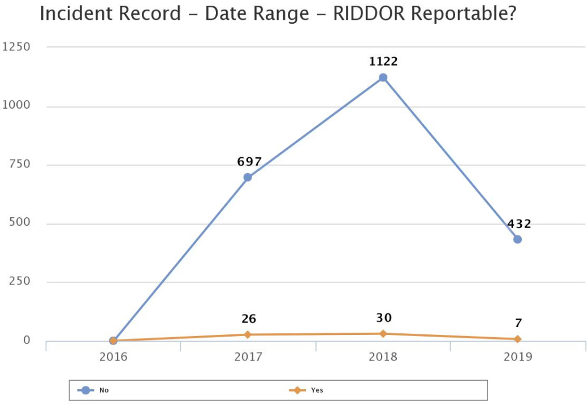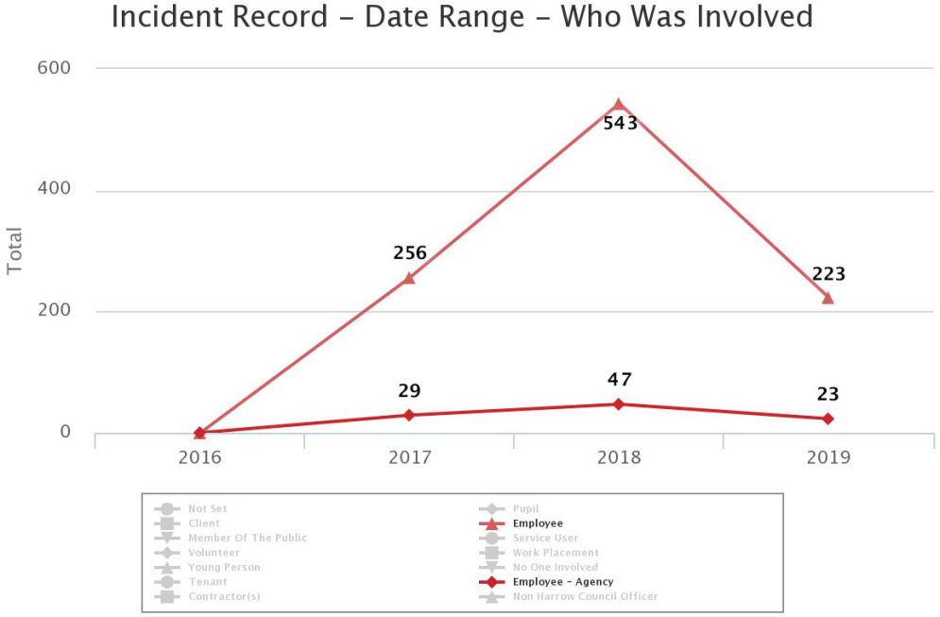

**APPENDIX 3 – HEALTH & SAFETY STRATEGY**



**OCCUPATIONAL**

**HEALTH AND SAFETY**

**STRATEGY**

**2019 - 2022**

**Corporate and Council Housing**

**Provision of service of:**

* **Health & Safety**
* **Fire Safety**
* **Asbestos Management,**
* **Occupational Health Management**
* **Employees Assistance**

|  |  |  |  |  |  |
| --- | --- | --- | --- | --- | --- |
|  | Name | | Signature | | Date |
| Prepared by: | John Griffiths | |  | | 22/02/2019 |
| Checked by: | Richard Lebrun | |  | |  |
| Approved by: | Paul walker | |  | |  |
| Document Title: | OCCUPATIONAL HEALTH & SAFETY STRATEGY 2019 - 2022 | | | | |
| Version Number: | 1 | Date of Next Review: | | 01/04/2020 | |

Occupational Health and Safety Strategy

*CONTENTS*

|  |  |
| --- | --- |
| **MANAGEMENT SUMMARY** | **2** |
| **INTRODUCTION** | **3** |
|  |  |
| **1.0 BACKGROUND** | **4** |
| * 1. The Current Situation   **2.0 CORPORATE HEALTH AND SAFETY GOVERNANCE OVERVIEW** | **4**  **6** |
|  |  |
| **3.0 PRIORITIES AND AIMS 2019 - 2022** | **9** |
| 3.1 Monitoring Progress Against Aims & Priorities | **11** |
|  |  |
| **4.0 HEALTH AND SAFETY MANAGEMENT SYSTEMS** | **12** |
|  |  |
| ***5.0 AUDITS (TEAM, PREMISE & PROCESS AUDITS)*** | **15** |
|  |  |
| **6.0 SELF-AUDITS AND SAFETY TOURS** | **16** |
|  |  |
| *7.0 SERVICE DELIVERY* | **16** |
| 7.1 Health and Safety, Fire and Asbestos Services | **16** |
| 7.2 Occupational Health Service | **18** |
|  |  |
| **8.0 RESOURCE ALLOCATION**  **9.0 CORPORATE HEALTH AN DSAFETY PLAN 2019/20** | **18**  **19** |
|  |  |

**MANAGEMENT SUMMARY**

It is essential to the achievement of our strategy for Health and Safety to ensure that access to the right knowledge, skills, and support is available to staff not only when, but also before, they need it, and that this is widely communicated and understood to achieve a culture of health and safety excellence. Key to achieving this is the actions and support of the Corporate Health and Safety Team through continuous improvement and maintenance of the safety management system (SMS) by qualified and competent safety practitioners.

In line with best practice the strategy and model for the safety management system follows the precepts laid down in the Health and Safety Executives guidance ‘Managing for health and safety (HSG (65)’. The strategy therefore is based on the principles of the Plan, Do, Check, Act approach and aims to achieve a balance between the systems and behavioural aspects of management. It also builds in health and safety management as an integral part of good management generally, rather than as a stand-alone system.

To achieve this, in addition to providing systems for policies, organisation planning, arrangements, training, communication and measurement there are clear objectives and monitoring of performance by the Corporate Health and Safety Team through health and safety management plans and proactive audit programmes.

In addition, the strategy looks to ensure all Directors, Managers, Department Management Teams and Service Managers lead by example by demonstrating best practice in health and safety management and ensuring whenever possible, that all management decisions further health and safety objectives.

This strategy is intended to incorporate the whole Council; it is about effective partnerships between managers, staff and unions who are all crucial to successful health and safety management. Poor health and safety management is rarely the result of malicious intent. Support by professional safety practitioners, training in health and safety skills and risk management are key to achieving a strong health and safety culture which benefits all staff, service users, pupils, visitors and contractors who work in our premises, and improves the quality of our service.

***INTRODUCTION***

The Health and Safety at Work etc Act 1974 places overall responsibility for health and safety with the employer. In this case the employer is Harrow Council and the expectation is that health, safety and wellbeing are, in turn, the responsibilities of the Chief Executive and Board of Directors. In respect of matters pertaining to Health, Safety, Welfare, Asbestos Management, Wellbeing and Occupational Health; the Chief Executive of Harrow Council is the Duty Holder.

Where suitable and sufficient competent advice and support is not available in organisations there will be clear failings in meeting legal requirements and hence considerable exposure to risk of prosecution to individuals and the organisation. Furthermore, there is additional exposure to moral failings, the cost of expensive litigation and reputational damage.

The Council’s corporate Health and Safety Team provides a Health & Safety, and Fire advisory service. Asbestos Management is managed by facilities management that facilitates risk reduction and helps develop or sustain inbuilt safety management. This should form part of the organisational management system that enables achievement of legal requirements. Specifically, as experienced practitioners, the teams are used to dealing with the processes undertaken by the local authority; they are experienced in the application and requirements of legislation and how it can be effectively applied judicially in this arena. In addition, provision of a comprehensive occupational health service with employee counselling and support service enables the Council to facilitate the well-being of all their employees.

The Council achieves its obligations in a number of ways that includes; a comprehensive system of occupational health support, employee counselling service, asbestos plans and surveys, safety processes, policies, guidance etc. Moreover, they can provide the, more intangible, experienced competent advice tailored to support the organisation.

This document sets out the strategy for Health and Safety, asbestos management and Fire Safety for Harrow Council for the three years between 2019 and 2022. It aims to build on the work already achieved to date in improving the health and safety management systems across the Council and thereby reduce illness, ill-health damage and loss, whilst continuing to deliver services to the people within the London Borough of Harrow.

**1.0 BACKGROUND**

In recent years legislation has reinforced the need for organisations to ensure effective management of safety, health, wellbeing, fire and asbestos. The Health and Safety Offences Act 2008, has increased penalties and provides courts with greater sentencing powers for those who break health and safety law. The Corporate Manslaughter and Corporate Homicide Act 2007 has meant organisations can be found guilty of corporate manslaughter as a result of serious management failures resulting in a gross breach of a duty of care.

Statutory obligations for health and safety arrangements can be found in the Health and Safety at Work etc Act 1974 and Management of Health and Safety at Work Regulations 1999 - specifically regulations 5 and 7 that refer to the need for competent advice and ensuring a suitable and sufficient safety management system exists (see also the Health and Safety Executive (HSE) HSG 65 Guidance).

The HSE, although the enforcing authority, are keen to point out that the many employers who do manage health and safety and wellbeing well, have nothing to fear from legislative requirements.

Harrow Council achieves high standards through the use ofan occupational health provider and established in-house services for health and safety. Harrow Councils Corporate Health and Safety Team consist of a three professional experienced, qualified safety practitioners. The team are fully aware of the impact and need for competent advice to ensure effective delivery of a health and safety management system.

*1.1 The Current Situation*

Corporate Health and Safety sits within the Community and Public Protection Service, being three members of staff with responsivity for the overseeing of the corporate health and safety system and provision of advice.

Occupational Health remained part of the function of the Human Resources Team, including the provision of service by Health Management Ltd (HML) which oversees fitness to work and vaccinations.

In terms of the Corporate Health and Safety Board, this is chaired by the Corporate Director for Community.

The Corporate Director for Community launched a refresh of health and safety within the council, setting up a new meeting hierarchy that put the frontline staff at the heart of health and safety in their areas through the use of safety teams.

The safety teams are a joint worker management team that assists the employer in creating and maintaining a safe workplace. The goal of the team is to enhance the ability of workers and employers to resolve safety and health concerns reasonably and co-operatively.

The strategy seeks to replicate joint worker safety across all directorates and all levels of the council.

The Council Corporate Health and Safety Team have three health and safety advisers that provide an advisory service that covers corporate and schools.

Together the team provides a comprehensive Safety Management System that provides organised processes with planning, policies, monitoring and ongoing review; a wide range of advice, guidance and assistance that includes: management of Asbestos, Occupational Health, Well Being, Health and Safety, Welfare and Fire Safety across the whole Council.

The Corporate Health and Safety Team comprehensive Safety Management System ensures that the Council reduces health and safety risks across the board. This, in turn ensures we meet with statutory obligations, minimise costs from losses or civil litigation and fulfil our moral obligations to all those affected by our undertaking which includes; employees, contractors, school pupils, those who visit, play or use corporate premises, or live in Council Housing. We do this by:

* Ensuring that health and safety remains a vital part of standard management practice across the Council and provide planning for this to be achieved;
* Providing information, advice and training to all employees to help them stay safe at work and understand their own responsibilities to themselves and others;
* Developing strategic and operational initiatives and reviews that properly address any Health, Safety or Fire related risks associated with Council Housing, Council operations, schools and premises;
* Ensuring provision of an Occupational Health Service for all employees;
* Ensuring that risk assessment remains the process by which hazards are identified and risks arising are eliminated or adequately controlled;
* Monitoring standards by undertaking; audits, inspections, asbestos surveys, investigating significant accidents and incidents and providing interpretation of Health and Safety legislation that impacts on the Council;
* Management that ensures protection from exposure to asbestos in or near any of our premises.
* Monitoring of contractors for Health and Safety particularly with regard to Council Housing.
* At the start of each new financial year set out a Corporate Health and Safety Plan detailing the planned programme of auditing that designated safety advisers will undertake.

In all cases, the primary intention is to utilise resources in a way that assists with the development and implementation of systems that proactively reduces risk and gives feedback on performance **before** an accident, incident or ill health.

**2.0 Corporate Health and Safety Governance Overview**

The Council Corporate Health & Safety Policy clearly sets out roles and responsibilities to meet the needs of health and safety.

To ensure a successful culture is the responsibility of all management. To this end, all Heads of Service shall be the primary lead for health & safety in their services, with a nominated person acting as safety representative for that service. This is in conjunction with any Union Health & Safety representative.

Safety circles have been introduced as a means of communication and tackling safety issues at the most appropriate level. They will be chaired by the Safety Circle Lead and involve staff and representatives of all of the services represented. Heads of Service should ensure that suitable representatives are nominated and that all risk areas covered. These meetings shall take place as a minimum every 2 months.

The purpose of these meetings is to:

* Involve managers and employees in achieving a safe and healthy workplace.
* Review safety-related incidents, audits
* Review management and Corporate H&S audits of the workplace, communicate identified hazards, and recommend immediate methods for eliminating or controlling them.
* Introduce and assist with workplace safety and health initiatives and recommend improvements to management.

The Safety Circle is a space to share information and discuss specific risks in the service areas represented and maintain a record of issues raised and actions completed.

All actions shall be recorded on the SHE Assure software, with clear timescales. A review will take place at the directorate management meeting to ensure actions are being followed up and information fed into the directorate risk registers monthly.

Updated risk registers and any areas of key risks are raised quarterly to the Directorate Joint Committee for discussion, including with Unions. Decisions to escalate to the Corporate Health & Safety Board shall be made at this point. All actions recorded on the SHE Assure software.

The Corporate Health & Safety Board will meet on a quarterly basis and will:

• Sign off all health & safety risk registers;

• discusses areas of concern and

• agrees items for future agenda items / areas of concern for DMTs and Safety Circles

Minutes of Corporate Board sent to Corporate Strategic Board and loaded onto SharePoint software. CSB will have the overview of corporate Health & Safety and Occupational Health / Wellbeing, and co-ordinate joint approach.

CSB retains overall governance of corporate health & safety, ensuring the aims and objectives are being met. They shall discuss any areas of concern and identify any issues they want to know more about or provide direction where needed.

Any actions resulting from CSB shall be recorded on the Assure SHE software and fed back to DMTs for action.

The Corporate Health & Safety Team shall oversee the process including being the administrators of the Assure SHE software. They shall also provide the relevant statistics and information to inform safety circles, directorate meetings and the corporate health and safety board

**Meeting Structure**

To be informed of all risks every 3 months associated with decisions, asked to approve or consider

Overview

Portfolio lead member.

Corporate Strategic Board

Corporate Health & Safety Board

Directorate Joint Committee

Directorate Management Meeting

Safety Circle

Employee Responsibilities

Overall responsible person

for corporate health & safety

within the organisation

Governance

Chief Executive

Delegated Lead for Corporate

Health & Safety, Including

chair of the Corporate

Health & Safety Board

Governance

Corporate Director - Community

Director responsible for

Corporate Health & Safety

Operational function

Strategy

Divisional Director – Environment & culture

Responsible for Corporate

Health & Safety function

which sits within service

Strategy/Ops

Head of Service – Community & Public protection

Operational Lead for Corporate

Health & Safety, including

Providing corporate policy’s,

procedures and advice

Operations

Corporate Health & Safety

Commercial Safety Team

Principal EHO – Commercial Safety

Team Leader – Commercial Safety

**3.0 PRIORITIES AND AIMS FOR 2019 - 2022**

Over many years the Corporate Safety Team has committed time and resource towards developing a comprehensive set of Corporate Health and Safety policies and supporting guidelines which are kept under review and audited against. These systems and procedures enable departments, in turn, to ensure the development of the necessary health and safety documentation that meets as minimum, statutory obligations together with corporate policies. To build on this, the following priories are highlighted for the next three years:

1. ***Maintaining and improving the Council’s safety management system***

Through supporting the Executive Management Team, Departmental Management Team, managers, with review and monitoring process which support initiatives, remediation and decision making.

1. ***Completing a series of audits, risk assessments and surveys***

This includes schedules for the following health, safety and fire processes:

* Internal fire and health & safety audits on identified teams, premises and processes for corporate and council housing buildings
* Audits in schools and children centres.
* Fire Risk Assessments for corporate, schools and council Housing.
* Fire Risk Audits for Corporate buildings.

1. ***Maintaining an Asbestos survey programme***

To locate, assess and monitor the condition of asbestos containing materials within the council’s corporate and Council Housing portfolio with schedules which includes:

* Corporate Asbestos survey programme
* Council Housing Asbestos survey – common parts (statutory) and void dwellings
* Schools asbestos survey programme (statutory)
* Asbestos awareness training
* Reactive response to Refurbishment & Demolition surveys and incidents

1. ***To support managers and staff in achieving suitable levels of health & safety competency;***

Effective management of health and safety involves people using their skills and knowledge to work safely. A fundamental requirement is for all managers to undertake British Safety Council Training to provide them with a solid grounding in the requirements of Occupational Health and Safety legislative requirements. Undertaking computer based training modules will ensure knowledge is continually professionally developed and reinforced. This will in turn help ensure managers have the basic skills to identify the health and safety competency needed by their staff.

1. ***To ensure the Occupational Health Service continues to provide adequate health surveillance, return to work rehabilitation, health promotion and reduction of work-related sickness absence;***

The Council will continue to work in close partnership with its appointed Occupational Health Service provider to ensure the most efficient use of service resources.

1. ***To build on the communication and consultation arrangements to ensure staff are fully involved and committed to achieving acceptable health and safety standards;***

To achieve success in health and safety management, there needs to be effective communication up, down and across the Council. Front line staffs are involved in communication primarily through the risk to their health and safety identified in their risk assessments, and the preventive and protective measures necessary to control risk. This is supported with safety circles, tool box talks that reinforce a process for direct consultation. Further to this, other means of communication include newsletters, and the council intranet.

At a more strategic level; all Directorates are to have effective health and safety committees with Executive Director Representation on the Corporate Health and Safety Committee. Representatives of each Directorate are expected at attend a Corporate Health and Safety Committee that now has a corporate lead (Corporate Director of Community) and steer on health and safety.

1. ***To encourage greater visible and active leadership on health and safety matters by managers;***

Active leadership is essential if the Council is to foster a positive health and safety culture. The Corporate Health and Safety Team have promoted this through making available British Safety Council training courses for both Senior Managers/Directors and those who managed staff.

1. ***To align health and safety more closely with the overall Risk Management arrangements;***

The Councils Risk Management Strategy aims to establish a culture where risks are understood and managed. Health and Safety management aims to ensure risks to health and safety are identified and managed. While Risk Management covers all business risks and is focused on the major risks to the Council, there are areas where the two strategies meet. Health and safety processes and arrangements should therefore be seen and understood as supporting the Risk Management Strategy. Significant health and safety issues identified during risk management assessments will therefore be communicated to the executive board.

1. ***To ensure good health and safety practice in our relationships with partners;***

As well as setting out to improve our own health and safety performance, the Council will work with its partners to improve health and safety overall in the delivery of its services. The aim will be to share knowledge and experience and at the same time provide managers overseeing contracts with feedback on safety standards.

**3.1 Monitoring Progress Against Aims & Priorities**

A number of proactive measurement activities take place to monitor safety performance for the Council. These measures are set out with performance targets in the Corporate Health and Safety Management Plan which is agreed by Executive Management Team at the start of the financial year.

The key measures against which progress will be assessed in meeting the strategic aims and priorities are;

* Number of audits and compliance levels achieved
* Number of Fire Risk Assessments and actions completed
* Number of Asbestos surveys completed
* Number of Asbestos re-inspections completed

Other methods of monitoring the success of the safety management system are**:**

* Review of accidents and statistics and related sick leave.
* Number of staff undergoing health and safety training
* Computer Based Training completed
* Senior managers safety tours completed
* Manager’s self- audits completed.
* Health and Safety performance reports
* Action status of items on risk registers

**4.0 HEALTH AND SAFETY MANAGEMENT SYSTEMS**

*The Management of Health and Safety at Work Regulations 1999 – Regulation 5 - requires Harrow Council to have arrangements in place for managing health and safety. Like any management system, it is essential that the Council collects information on the system implemented if it is to be able to make judgements about its adequacy and performance.*

*The system followed by the Corporate Health and Safety Team is based on that described in HS(G)65* Successful Health and Safety Management*. Diagram 1 illustrates the system showing the main topic headings and the communication flows by which continuous improvement in health and safety management is achieved. Health and safety audits aim to verify compliance with each aspect of the management system:*

*Information link*

*Control link*

### Policy

### Organising

### Auditing

### Planning & Implementing

### Measuring

### Performance

### Reviewing performance

*Diagram 1: HS(G)65 Health and Safety Management System Elements*

|  |
| --- |
| ***POLICY***  Effective health and safety policies set a clear direction for the Council to follow. They contribute to all aspects of business performance as part of a demonstrable commitment to continuous improvement. The Council already has a well-developed set of Corporate Policy Arrangements that are available on the council SHE software system and this is subject of a rolling programme of review. |

|  |
| --- |
| **ORGANISING**  The Council needs to ensure that it has an effective management structure and arrangements are in place for delivering its health and safety policies. To achieve success, all staff will need to be motivated and empowered to work safely and to protect their long-term health, not simply to avoid accidents. The Council is currently embarking on developing a safety circle safety culture, ensuring robust health and safety management supports this programme and will better shape the way it deals with health and safety issues in the future. The activities necessary to promote a positive health and safety culture are;  ***Control***  Everyone working in the organisation can contribute to controlling health and safety risks. Control is achieved by getting the commitment of employees to clear health and safety objectives. Managers will need to take full responsibility of controlling factors that could lead to ill health, injury or loss thereby helping to create a positive atmosphere and encouraging a creative and learning culture.  ***Co-operation***  Participation is essential to control risks effectively. By encouraging employee ‘ownership’ of health and safety policies this will assist with their better understanding that the organisation as a whole, and people working in it, benefit from good health and safety performance.  The Council has a legal obligation to consult with all employees about those health and safety issues in the workplace that affect them. The Council has already fostered good relationships on health and safety matters with its recognised trade unions.  ***Communication***  All managers need to lead by example. Their visible commitment to, and involvement in, health and safety management should be obvious and consistent. They will need to provide regular and reliable information on health and safety to everyone who needs it.  ***Competence***  If Council employees are to make a maximum contribution to health and safety, the Council will need to have in place robust arrangements to ensure that they are competent. Health and safety is already a mandatory competency for all employees. |

|  |
| --- |
| ***PLANNING AND IMPLEMENTING***  This element concerns the adoption of a planned and systematic approach to implementing the health and safety policy through an effective health and safety management system. The aim is to minimise risks. This strategy provides the framework, against which the Council will judge the adequacy of its health and safety management systems to ensure,   * The mitigation of risks; * The ability to react to changing demands; * Sustainability of a positive health and safety culture. |

|  |
| --- |
| ***MEASURING PERFORMANCE***  The Council needs to measure what it is doing to implement its health and safety policy and to assess how effectively risks are controlled. There are many different types of monitoring, but they can generally be categorised as either ‘proactive or reactive’.   * **Proactive** methods monitor the operation of management arrangements and workplace precautions and tend to be preventative in nature, for example; routine inspections and surveys of premises, plant and equipment by staff; * **Reactive** methods monitor evidence of poor health and safety practice but can also identify better practices that may be transferred to other parts of the organisation, for example, investigating accidents and incidents, monitoring cases of ill health and sickness absence records   Where services are delivered on behalf of the Council via contractor relationships, these activities should also be subject to continual health and safety performance monitoring and review. In such circumstances, the level, nature and frequency of monitoring undertaken will be based on an assessment of risk. Evidence of such systems will be required to enable demonstration of due diligence. |

|  |
| --- |
| ***REVIEWING PERFORMANCE***  All control systems tend to deteriorate over time. To provide essential feedback and information to managers, on how effectively plans and the components of the health and safety management systems are being implemented, professional safety and health advisers from the Corporate Health and Safety Team carry out a regime of regular auditing and performance review of ***premises, teams and processes***. The findings on success and failure are then fed back in to the system and should be acted upon to enable continuous improvement to be made. |

***5.0 AUDITS (TEAM, PREMISE & PROCESS AUDITS)***

***5.1 Team Audits:***

Team audits are necessary to verify that appropriate safe systems of work are operating across the division. These audits focus in on staff training, team risk assessments and safe systems of work.

The categorisation of teams will be based on:

* **The activities of the team/service** – front facing staff interacting with the public are generally deemed to be at a higher risk to workplace aggression especially when working alone. Similarly, teams using dangerous equipment e.g. chainsaws, abrasive wheels or engaged in high risk activities such as working at height.
* **Where there is thought to be an absence of suitable team assessments and safe systems of work** the team will be targeted.
* **Any other significant hazards** that may be identified.

**5.2 Premise Audits:**

Premise audits are required to ensure compliance of buildings and assets. These audits focus on statutory requirements and industry good practice relating to aspects of Corporate Landlord. Every corporate building will be audited within an 18 month circle.

The categorisation of premises will be based on;

**The physical location;**

The location category will be based on known untoward activity in the area of the premises, its remoteness and proximity to essential emergency services.

**The use and occupiers of the premise/site,**

Use of the building/premises will be based on a sliding scale from office use, being inherently safe, to depots being dangerous because of transport movement. Sites made available to the public especially where there is no onsite supervision will similarly tend to present a higher risk due to factors like vandalism. The amount and variety of mechanical systems in the building will also need to be taken into account, that is water, sanitation, washing systems, air conditioning, (all potential legionella hazards), lifts (goods & passenger) will raise the risk profile on the basis that the more systems the more maintenance is required.

**Sites where vulnerable persons reside** (i.e. Residential Care and Sheltered Housing Schemes) will need higher levels of oversight,

**Any other significant hazards that may be identified**.

**5.3 Process Audits:**

*Process audits enable us to identify systemic problems within managed processes and enable effective remediation of risk across boundaries.*

The categorisation of processes will be based on;

* **Where there is reliance on contractors to fulfil essential aspects**; for example repair and maintenance contracts,
* **The overall success of the process is dependent on input from several teams**; for example the maintenance of play areas.

***6.0 SELF-AUDITS AND SAFETY TOURS***

*The program of audits carried out by the Corporate Health and Safety team is supported with ‘Self-audits’ by Managers and ‘Safety Tours’ by Senior Managers.*

*The managers ‘Self-audit’ comprises of question sets and requires reference to sample inspection of documents and a physical inspection of the premises. The senior managers ‘Safety tours’ are a more general approach relying on observation and talking to staff.*

*Both audits aim to breach the gap and ensure that all areas of the Council are examined each year. Further information can be found under the Corporate Health and Safety Assure SHE system.*

***7.0 SERVICE DELIVERY***

Corporate Health and Safety Team services will be delivered by fully trained, qualified, experienced competent persons with a detailed knowledge of legislative requirements, good practice and understanding of fire safety, Asbestos Management, Occupational Health Management, Employee Counselling and Health & Safety Law. The teams are able to provide support on wellbeing, health and safety issues that can be applied so not as to be onerous in its application to achieve service aims.

**7.1 Health and Safety, Fire and Asbestos Services include**:

* **Auditing** - Essential in the first instance to identify shortfalls and recommend course of action to ensure an effective safety management system. The Safety Management System provides robust and comprehensive audits for Premises, Teams and Processes.
* **Policies and Arrangements** – Developed, updated and reviewed Council Corporate Policies, Processes, Guidance & Briefing Notes providing suitable and sufficient, arrangements, information for Managers and Premises controllers to follow for practical application.
* **Risk Assessments** - A comprehensive set of risk assessment processes (including DSE, work, Stress, Manual Handling, New and Expectant Mothers, etc) that are in line with HSE approved systems together with model assessments and advice on their use. The team will also support and assist managers with the production of specific risk assessments.
* **Fire Risk Assessments** - For Council Housing, experienced qualified fire risk assessor will undertake predominantly Type 1 Fire Risk Assessments over a cyclical programme. High priority buildings, Sheltered Housing Schemes, Community Halls and Converted Street Properties) being risk assessed annually whilst Medium/low priority (purpose built blocks are assessed over a two year cycle. Type 4 assessments in high rise void properties will be undertaken as and when suitable properties become available.
* **Advice/Professional support and guidance** - by expert officers for Health, Safety, Asbestos and Fire related issues.
* **Asbestos Management** – The council corporate health and safety team will provide asbestos management policy and guidance, awareness training and offer help in the application of recommended and required management processes. Facilities Management will follow the policy when dealing with asbestos in the corporate buildings and schools
* **Asbestos register** - Access to an on-line asbestos management suite that holds records and surveys for properties surveyed by specialist asbestos surveyors, via facilities management, Council Housing employ an asbestos surveyor.
* **Asbestos Surveying service and Management Plan**. It is a requirement of the Control of Asbestos Regulations 2012 that premises set out in a detailed plan how asbestos is managed. The Council as the Duty holder has this work carried out by a licenced asbestos contractor.
* **Training** - Provision of health and safety and asbestos training from a range of courses by competent staff. Asbestos awareness training is a requirement of the Control of Asbestos Regulations 2012. This is provided to all those in control of premises and those who may be designated as carrying out any work with asbestos or with the planning or arrangement of that work.
* **Access to a Computer Based Training (CBT)** - A wide range of modules including asbestos management, fire safety, health and safety awareness etc. This is provided to reinforce knowledge and act as an easily accessible way to complete refresher training.

* **Accident/ Incident Reporting** - Provision of an on-line system for reporting and maintaining records (Assure SHE software). The reporting system acts as a tool to provide data, graphs and statistics that enables analysis of trends to aid with risk mitigation, defence in litigation and reduces insurance costs.
* **Accident/ Incident Investigation -** All accidents that may be deemed necessary for an officer to conduct a full accident/incident investigation can be advised and supported to ensure a professional approach and documentation.
* **Support, advice and liaison with enforcing authorities are provided**. Experience has shown that liaison with enforcing authorities using safety professionals has resulted in positive outcomes.
* **Site Inspection/ Visit** – A Health and Safety professional are available to attend sites to monitor and advice on specific issues.
* **Violence at work and Lone working systems** – The team will work alongside management in providing a suitable lone working solution.

**7.2 Occupational Health Service**

The Occupational Health Service provides:

* A Consultant-led team focus on early intervention, executing tried-and-tested approaches that will help to safeguard employees’ health and get them back on their feet as quickly as possible.
* Strategies to assist with managing employees more decisively.
* Development of coordinated plans so staff can return to work as soon as possible.
* Employees can visit the Occupational Health providers clinics where required.

**8.0 RESOURCE ALLOCATION**

A key area of support of the Corporate Health & Safety Team is to undertake external monitoring of the implementation of departmental safety management arrangements. Each Directorate receives a level of professional support from the team of Safety Advisers. The amount of resource allocated to each Directorate is based on the level of risk associated with the undertakings of teams.

A significant amount of work is outsourced to contractors. This equally requires safety monitoring to ensure not only legislative compliance but avoidance of reputational damage. One particular area requiring significant monitoring across the Council concerns compliance with Client duty holder responsibilities under the Construction (Design and Management) Regulations 2015, which takes in construction, repair and maintenance work.

**9.0 CORPORATE HEALTH AND SAFETY PLAN 2019/20**

Corporate Health & Safety Management Plan

2019 – 2020

|  |  |
| --- | --- |
| Prepared by: | John Griffiths  Corporate Health & Safety and Compliance Manager |
| Approved by: | Paul Walker  Corporate Director of Community |
| Director’s Signature |  |
| Date | 1st April 2019 |
|  |  |

| **Section** | **Objective** | **Start Date** | **End Date** | **Lead** | **Target** | **Achieved** | | **Remarks** |
| --- | --- | --- | --- | --- | --- | --- | --- | --- |
| **Six Months** | **End Period** |
| ***Safety Management*** | | | | | | | | |
| **Senior Managers Safety Tours**  **(Linked to priorities and Aims (A,B,D,G,H,I)** | 1. Conduct safety tours of premises/ sites within areas of responsibility, a **minimum of four** a year (quarterly), to ensure the safety and upkeep of the workplaces. | *April 2019* | *March 2020* | *Directors/HOS* | *100%* |  |  | Directors and HOS can jointly carry out workplace inspections |
| (b) Record the results of safety tours and submit quarterly returns (Proforma) to Corporate Health & Safety Team for review at Safety Committee and Management Team meetings. | *April 2019* | *March 2020* | *Directors/AD’s* | *100%* |  |  | To be discussed at Department Team Meetings at least quarterly and minuted |
| **Management Self Audits**  **(Linked to priorities and Aims (A,B,D,G, H,I)** | 1. First line or second line managers/supervisors to carry out **one** Management Self Audit per year on areas of responsibility. | *April 2019* | *March 2020* | *First/second Line managers to carry out audits, Directors to ensure audits take place.* | *100%* |  |  | Directors to ensure process take place. Where H&S team have audited, these count in lieu of self-audits. |
| 1. Management of Self Audits; Managers to remediate actions and provide Directors with information. Directors to maintain record system and report quarterly to Corporate Health & Safety Team | *April 2019* | *March 2020* | *First/Second Line managers to follow up and ensure actions completed.* | *100%* |  |  | Safety Circle Leads to maintain record that this has been carried out by their teams. Information to be sent quarterly to the Directors by team/line manager. |
| ***General Health & Safety Control Systems*** | | | | | | | | |
| **Corporate H&S Audits by Department**  **General Audits**  **(Linked to priorities and Aims (A,B,D,H,I)** | Create and undertake a schedule of Internal Health, Safety and Fire Safety Audits on identified teams and premises. Focus to be on processes as part of audit where applicable. **Overall 24 audits.**  **12 Corporate and 12 audits in Environment and waste strategy** | *April 2019* | *March 2020* | *Corporate H&S Team* | *24 audits* |  |  | Audits will be on high/medium risk as determined by previous audits, use, size and incidents over the last two years of historical data. |
| **Schools & Children Centres**  **General Audits**  **(Linked to priorities and Aims (A,B,H)** | To start new cycle of audits a minimum of 12 audits, schools and children centres to attend to actions as required. | April 2019 | March 2020 | *Corporate H&S Team* | 12 audits |  |  | Audits will be on high/medium risk as determined by previous audits, use, size and incidents over the last two years of historical data. |
| ***Corporate Policies/Committees*** | |  |  |  |  |  |  |  |
| **Corporate Policies**  **(Linked to priorities and Aims (A,H,I)** | Review Corporate Policies and Guidance documents in light of changing legislation, official guidance, good practice and Council priorities. Identifying where changes required, re-date/reorganise library of documentation on SHE software system. Target minimum of 12 policies. | *April 2019* | *March 2020* | *Corporate H&S Team* | *12 fully revised or written policy/guidance documents* |  |  | Policies will be reviewed on a risk based basis. All new or revised policies must be consulted through the Corporate H&S committee members. |
| **Corporate Health and Safety Committees**  **(Linked to priorities and Aims (A,B,C,F,H,I)** | Plan, organise and attend Quarterly H&S Committee Meetings | *April 2019* | *March 2020* | *Corporate H&S Team, representative’s senior managers, Committee Chairman, and Union/safety Representatives.* | *4* |  |  |  |
| ***Fire Control Systems*** | | | | | | | | |
| **Corporate**  **Fire Safety Audits**  **(Linked to priorities and Aims (A,B,H,I)** | 1. Conduct a **minimum of 10 audits** of fire safety, identified as the top high risk corporate premises and managers actions within time scales | *April 2019* | *March 2020* | *Facilities Management* | *10* |  |  | Audits will be on high/medium risk as determined by previous audits, use, size and incidents over the last two years of historical data. |
| 1. Conduct a **minimum of 20 audits** of fire safety on identified schools premises in support of external audit of schools, Head Teachers to address actions within time | *April 2019* | *March 2020* | *Facilities Management* | *20* |  |  | Audits will be on high/medium risk as determined by previous audits, use, size and incidents over the last two years of historical data. |
| **Council Housing**  **Fire Risk Assessment**  **(Linked to priorities and Aims (A,B,H,I)** | 1. Carryout Fire Risk Assessments in all **High Risk** Priority common areas (4 or more stories/house) vulnerable persons/community halls and relevant team to attend to actions. | *April 2019* | *March 2020* | *Council Housing Team.* | *39 FRAs* |  |  |  |
| 1. Carryout Fire Risk Assessments in **Low Risk** Priority Common areas (Between 1 & 3 stories/purpose built and relevant team to attend to actions. | *April 2019* | *March 2020* | *Council Housing Team* | *70 FRAs* |  |  |  |
| **Council Housing**  **Fire Safety Audits**  **(Linked to priorities and Aims (A,B,H,I)** | Carryout audits of fire safety at high priority sites: | *April 2019* | March 2020 | *Council Housing team* | 25 |  |  |  |
| 1. Audit Sheltered Housing Schemes and relevant team to attend to actions | *April 2019* | *March 2020* | *Council Housing team*. | *17* |  |  |  |
| 1. Audit Community Halls and relevant team to attend to actions | *April 2019* | *March 20209* | *Council Housing team*. | *8* |  |  |  |
| ***Workplace Implementation*** | | | | | | | | |
| **Health & Safety Training**  **(Linked to priorities and Aims (B,F,G,I)** | 1. Identify suitable Health & Safety training opportunities as identified by department Directors/ Safety Rep’s/HOS/safety circle leads. | *April 2019* | *March 2020* | *Directors and safety Circle leads* | *40 Trained staff* |  |  |  |
| 1. All **Directors / Senior Managers** to have attended Senior Managers British Safety Council one day Training course. | *April 2019* | *March 2020* | *Directors/ HOS* | *100%* |  |  | Mandatory for all senior managers |
| 1. All **First Line Managers and Supervisors** to attend the two day British Safety Council course. | *April 2019* | *March 2020* | *Directors/HOS* | *100%* |  |  | Mandatory for all managers |
| **Learning POD Training and Development**  **(Linked to priorities and Aims (D,E)** | All **employees have** to complete the following Training.   * Using a Workstation * Fire Safety * Safety Circle | *April 2019* | *March 2020* | *Directors / HOS/Corporate H&S Team/Safety Circle Leads* | *100%* |  |  |  |
| ***Asbestos Management*** | |  |  |  |  |  |  |  |
| **Corporate Buildings Asbestos Surveys**  **(Linked to priorities and Aims (A,B,C,H)** | To carry out asbestos surveys in all corporate buildings. | *April 2019* | *March 2020* | *Facilities Management* | *20* |  |  | To meet employers statutory duties under Regulation 4 of CAR 2012. |
| To carry out asbestos re-inspection survey to look at process and verify integrity of asbestos works by contractors, facilities Management to attend to any identified failings. | *April 2019* | *March 2020* | *Facilities Management.* | *20* |  |  | This will ensure processes are working and that we are carrying out a due diligence check. |
| **Community Schools and Schools with SLA Asbestos Surveys**  **(Linked to priorities and Aims (A,C,H)** | 1. To review management plans and results from surveys and carry out actions identified. There will be a minimum of 20 schools surveyed with Management Plans. Schools to attend to actions. | *April 2019* | *March 2020* | *Faculties Management /Head Teachers* | *20 schools* |  |  | To meet employers statutory duties under Regulation 4 of CAR 2012 - Community Schools LBE as the Duty Holder |
| **Council Housing Asbestos Surveys**  **(Linked to priorities and Aims (A,B,C,H)** | 1. To carry out and manage a Surveys on Housing stock   This will be risk based and client directed. Council Housing to attend to required actions. | *April 2019* | *March 2020* | *Council Housing* | *275 surveys* |  |  | To meet employers statutory duties under Regulation 4 of CAR 2012. |
| ***Communications*** | |  |  |  |  |  |  |  |
| **Corporate Health and Safety Handbook**  **(Linked to priorities and Aims (E,F,G,H,I)** | (a) To roll out the new corporate H&S handbook to all employees | *April 2019* | *July 2029* | *Corporate health and safety* | *100%* |  |  | Provide paper and electronic versions. |
| **Communication Channels to promote key health and safety performance measures to employees.**  **(Linked to priorities and Aims (F,G,H,I)** | 1. Safety Circle leads to provide dates and key risks of safety circles. Corporate Health and Safety to provide feedback on key risks to these safety circles. | *April 2019* | *March 2020* | *Safety circle Leads* | *At least one a quarter* |  |  | This will be monitored on SHE Assure |
| 1. Corporate Health and Safety to promote key health and safety initiatives via Communications each month by the corporate newsletters. | *April; 2019* | *March 2020* | *Corporate health and safety team* | *monthly* |  |  |  |
| 1. Corporate Health and Safety Board provide a report on key risks. | *April 2019* | *March 2020* | *Corporate Health and Safety Board Chair* | *Quarterly* |  |  | The corporate Health and Safety Board will meet on a quarterly basis and will discuss areas of concerns/risks to the organisation and agree future agenda items and areas of concern for DMT’s and Safety Circles. |



**APPENDIX 4**

Corporate Health and Safety Board

Terms of Reference

**Aim**

The Corporate Health and Safety Board will act on behalf of the Chief Executive as the strategic focus for Health and Safety across the corporate estate, using the Health and Safety Policy Statement as framework for decision making. The Board will ensure the implementation of the policy statement through agreed best practice and development of a Health and Safety management system.

**Accountability**

The Corporate Health and Safety Board will provide progress reports to the Corporate Strategic Board (CSB).

**Objectives**

The Corporate Health and Safety Board has the following objectives:

* To provide a forum in which officers and others with specific responsibilities for health and safety, as set out in the Health and Safety Policy, are held accountable for and supported in their actions. These actions are:
* To ensure compliance with the requirements of health and safety legislation and regulations. throughout the Council.
* To ensure arrangements for developing health and safety competencies among managers and staff are in place and are being followed.
* To review and approve Council-wide objectives for health and safety, policy and strategies and initiatives for their delivery, in consultation with the Governance, Audit and Risk Management Committee (GARMSC).
* To promote engagement with, and the integration of, health and safety considerations into everyday working practices in Council services.
* To lead on Occupational Health initiatives to promote well-being and stress management as part of the wider health & wellbeing agenda.
* To develop and oversee the development, implementation and regular updating of the Council’s strategic and operational health & safety risk register.
* To set and monitor performance indicators/standards for health and safety and monitor the Council’s arrangements for monitoring
* To commission audits and reviews of health and safety management systems, policies and procedures.
* To receive reports and feedback from Directorate Health and Safety Meetings or other relevant forums, groups or committees, as well as provide direction and information back to them as relevant.
* To consider reports on accidents and/or incidents, complaints and work related ill health statistics in order to identify any emerging trends or patterns.
* To consider reports on visits, inspections or any enforcement action taken by the Health and Safety Executive, the London Fire & Emergency Planning Authority and other enforcing authorities.

**Representatives**

The Corporate Health and Safety Board will be chaired by the Corporate Director Community with responsibility for establishing and implementing a strategic framework for the Health and Safety committees in each Directorate to achieve the aims set out above.

The Board shall consist of a nominated Divisional Director representative from each Directorate, a nominated Senior HR representative, representatives from the Unions and supported by the Corporate Health and Safety Team.

All representatives on the Board will have a voice in decision making. The chair / vice chair shall have the casting vote if the matter cannot be resolved by unanimous agreement. In matters that cannot be resolved, they will be passed to the Corporate Strategic Board, as the most senior strategic forum chaired by the Chief Executive, or Employee Consultative Forum (ECF) should it not be feasible to make a decision. The Unions retain the right to escalate matters of concern to an ECF Sub-Group / ECF in line with the consultative framework of the Council and Trade Union Recognition Agreements.

When a representative cannot make the meeting, a nominated person of sufficient grade shall attend and represent them

**Duties of the chair**

* Schedule regular Board meetings.
* Develop written agendas for conducting meeting.
* Maintain and action plan and log of decisions
* Conduct the meeting.
* Approve Board correspondence and reports.
* Supervise the preparation of meeting minutes.

**Duties of the vice-chair**

* In the absence of the chair, assume the duties of the chair.
* Perform other duties as directed by the chair.

**Conduct of the Board**

The Chair is responsible for ensuring that the Board meets on a monthly basis to resolve issues and take forward the objectives and aims as set out in this document.

The Board should not be cancelled or postponed except in exceptional circumstances. If any member of the Board cannot attend a deputy shall attend in their absence. If the meeting has to be postponed, a date for the next meeting should be agreed and announced as soon as possible by the Chair.

The minutes of each meeting will be supplied to every Board member once agreed by the Chair as soon as possible after the meeting, and be made available on the intranet once agreed.

A copy of the agenda and any accompanying papers should be sent to all members at least one week before each meeting.

**Consultation**

The Board actively supports and participates in the consultative arrangements in line with Safety Representatives and Safety Committee Regulations 1977 as amended by the Health and Safety (Consultation with Employees) Regulation 1996 and the Management of Health and Safety at Work Regulations 1999

All Corporate Health and Safety Policies and Procedures shall be presented to the Corporate Board for consultation and agreement of any other party that needs be involved. Comments will be provided within a 4 week consultation period, will be collated by the Corporate Health and Safety Team, and discussed at the next Corporate Board for final sign off.

**Directorate Health & Safety Board**

The Corporate Health & Safety Board will feed into, and receive information and referrals from, the Directorate Health & Safety Boards, of which there will be three. The three Directorate Health & Safety Boards shall be chaired by Director (Environment & Culture) for Community Directorate, Head of Finance for Resources Directorate and Divisional Director (Educational Services) for People Directorate.

These Directorate Health & Safety Boards shall be held quarterly and minutes and actions fed back to the Corporate Health & Safety. Key themes / agenda items will be determined from the Corporate Health & Safety Board, as well as be influenced by the needs of the services. These Directorate Boards shall be run as per the principles of the Corporate Health & Safety Board Terms of Reference.

**Appendix 5 – Occupational Health Overview 2018-19**

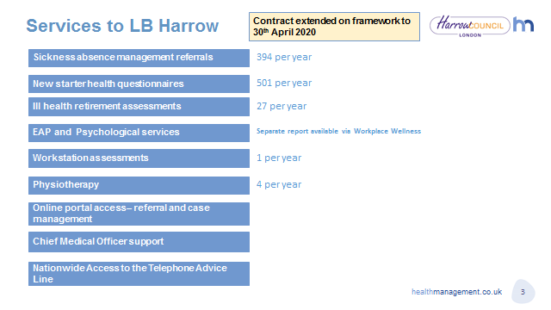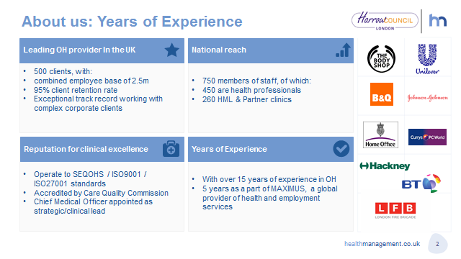

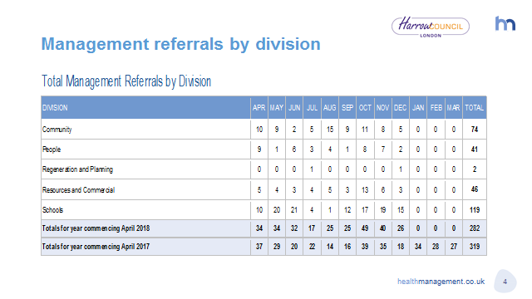

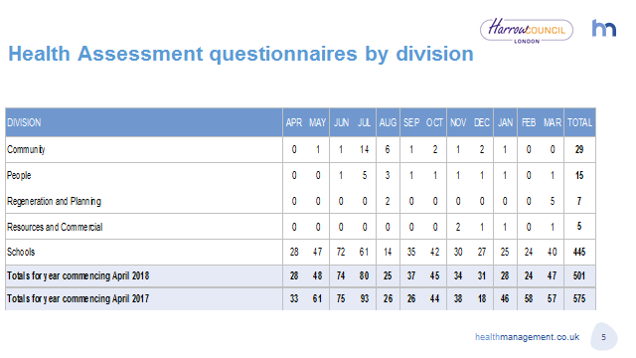

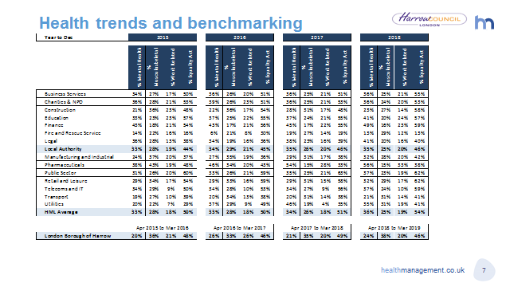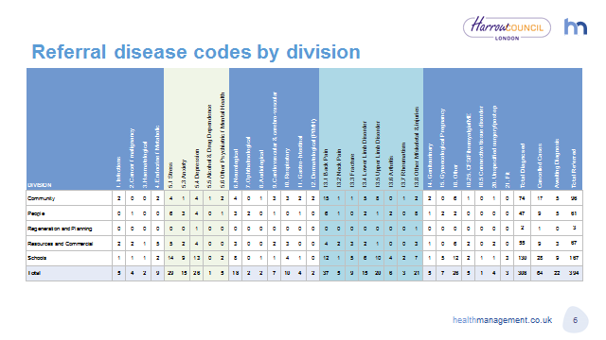

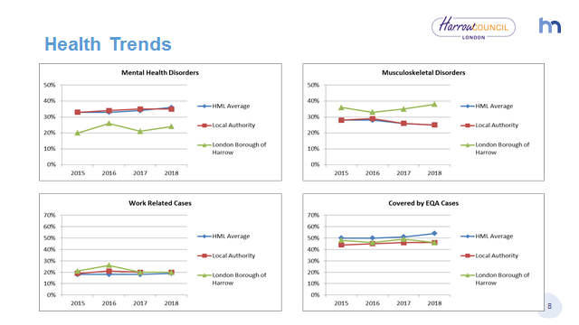



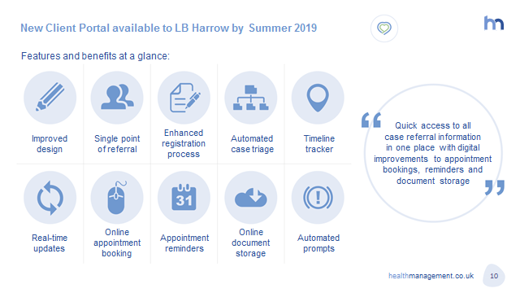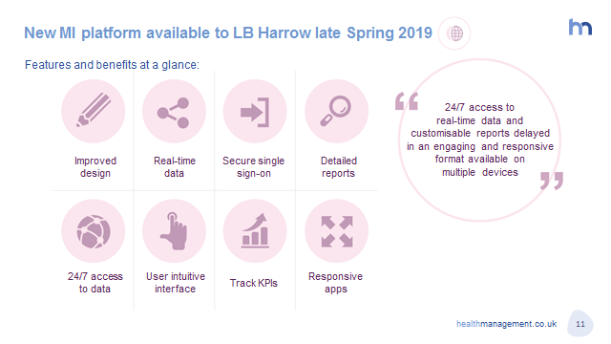

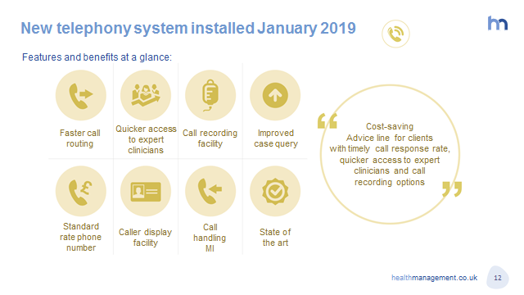

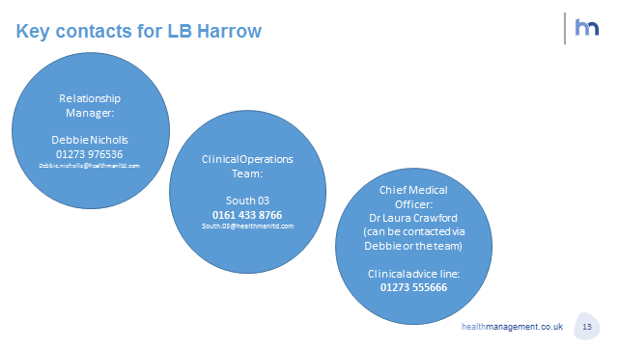

**Appendix 6 – Health and Safety Policy 2019-20**



**Corporate**

**HEALTH AND SAFETY**

**Policy**

**2019 - 2020**

|  |  |  |  |  |  |
| --- | --- | --- | --- | --- | --- |
|  | Name | | Signature | | Date |
|  |  | |  | |  |
| Prepared by: | Fredah Zuleha | |  | | 5/05/2018 |
| Checked by: | John Griffiths | |  | | 12/02/2019 |
| Approved by: | Paul walker | |  | |  |
| Document Title: | OCCUPATIONAL HEALTH & SAFETY STRATEGY 2019 - 2022 | | | | |
| Version Number: | 9 | Date of Next Review: | | 1st April 2020 | |

CONTENTS

|  |  |  |
| --- | --- | --- |
| **Section** |  | **Page** |
| 1 | Corporate Statement of Health & Safety Policy | 3 |
| 2 | Purpose | 4 |
| 3 | Organisation | 5 |
| 4 | Health & Safety Arrangements | 16 |
| Appendix 1 | Commercial Team – Corporate Structure | 16 |

|  |  |  |
| --- | --- | --- |
| **Acronyms** |  |  |
| CHSG | Corporate Health and Safety Group |
| CHSS | Corporate Health and Safety Service |
| CHSP | Corporate Health and Safety Plan |
| ECF | Employee Consultative Forum |
| HSCOP | Health and Safety Code of Practice |
| CSB | Corporate Strategy Board |
| OHS | Occupational Health Service |
| EAP | Employee Assistance Programme |
| HSE | Health and Safety Executive |
| GNs | Guidance Notes |
| ACoP | Approved Code of Practice |
| SSoW | Safe Systems of Work |  |

**1. Corporate Statement of Health & Safety Policy**

Harrow Council, as an employer, recognises its legal responsibility to make every effort and secure the health, safety and welfare of all its employees and others, i.e. visitors, contractors, service users etc. that may be affected by the Council’s undertaking.

The Council aspires to achieve excellence thereby implementing and effectively maintaining a robust safety management system that will permit safe work practices without compromising the health, safety and wellbeing of employees, the general public and the environment.

Harrow council recognises that success in achieving and maintaining a safe and healthy work environment incorporates commitment from both senior management and all employees within the organisation along with effective communication, co-operation and consultation.

The Council is committed to continuous improvement in health and safety performance and will develop a Corporate Health and Safety Improvement Plan which will include key targets and objectives for improvement in health and safety management.

In particular, it is corporate policy to;

* Meet and whenever possible exceed the minimum standards set by the Health and Safety at Work etc. Act 1974 and supporting regulations and guidance
* Provide financial and physical resources to ensure that the Council’s health and safety arrangements are implemented and adequately maintained.
* Regularly monitor and revise the health and safety management system, including this Policy Statement, other corporate Policies and Codes of Practice, to ensure that these documents remain in circulation and in date.
* Carry out appropriate risk assessments, seeking to eliminate and or reduce hazards. Where risk assessments have revealed risk levels to be unacceptably high, health and safety requirements will therefore take precedence over all other business requirements to ensure that these levels are reduced a low level as reasonably possible.
* Seek continuous improvement in health and safety performance; promote a proactive safety culture and to effectively maintain a safer and healthier working environment.
* Ensure that all employees receive adequate training for the purposes of health and safety
* Consult with employees or their representatives, on health and safety matters, also ensuring that the corporate Safety Policy is available when required.
* Ensure that competent persons are appointed to assist the Council in meeting its statutory obligations.
* Recognise that accidents usually result from failings in management control and are not necessarily the fault of the individual/s involved.
* Recognise that the Chief Executive has overall responsibility for ensuring that health and safety in the workplace is considered in all Senior Management Team decisions and allocating resources to support quality improvement programmes aimed at continual improvement.

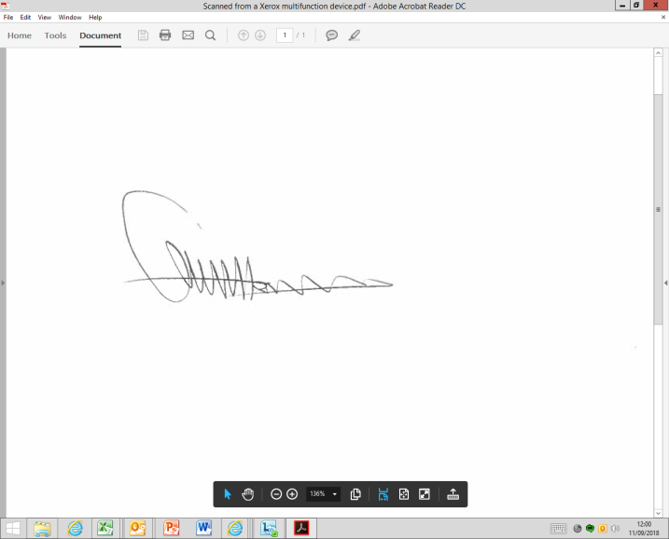

cid:image002.jpg@01D4F438.12B82170

**Sean Harriss Graham Henson**

**Chief Executive Council Leader**

**Date:** **Date:**

*2. Purpose*

This Policy and in conjunction with local documents, Codes of Practice (CoP) and Guidance Notes (GNs) will permit understanding how health and safety is managed across the Council as well as defining Senior Management roles and responsibilities.

The Policy is divided into principles, Organisation (people) and Arrangements (systems) and provides the framework for health and safety management within the Council.

**2.1 Scope**

This is a corporate Policy that applies to all employees including school staff, agency staff, consultants, contractors and volunteers.

**2.2 Elected Members**

The Elected Members have overall responsibility for the application of health and safety legislation, achieving the objectives set out within this Policy and ensuring that adequate resources are available to meet the organisation’s health, safety and welfare needs. The Elected Members delegate the work required to the Chief Executive.

**2.3 Principles**

Harrow Council recognises and accepts it’s statutory, moral, legal and economical responsibilities; fundamentally aiming to ensure that all employees, stakeholders and the general public do not suffer injury or ill health that may occur as a result from the Council’s undertakings.

Harrow Council’s Health and Safety Management System is based on the following model:

As defined by the Policy Statement and objectives.

The organisational structure used to implement the Policy is set down in the ‘Responsibilities’ section.

The methods of planning and targeting resources and implementing procedures

Methods of measurement to check that control strategies are working.

Feedback loop to improve performance.

AUDITING

POLICY

REVIEWING PERFORMANCE

ORGANISING

PLANNING & IMPLEMENTING

* Risk Control
* Employee Capability & Competence

MEASURE PERFORMANCE

* Reactive Monitoring
* Active monitoring

Independent auditing to check that the systems are implemented and effective.

For the model to be successful, the following standards must be applied:

* Ensuring that a health and safety management system is implemented to provide a structured management approach to controlling workplace hazards and risks throughout the organisation
* Ensuring that all employees undertake their tasks without disregarding health and safety
* Active commitment from Senior management to improving health and safety standards, making reference to European law and UK health and safety legislation in order to meet minimum standard
* Ensuring that the necessary resources are available to effectively meet the requirements of this Policy
* All level management to actively demonstrate a positive attitude towards workplace health and safety, encouraging employees to ensure that safe practice is routine
* Employees’ participation, including contractors, consultants and volunteers, working on Council premises, to pay maximum attention to the health and safety aspects of their work, embracing safe work practices to avoid injury / ill-health to themselves and to others.

**3. ORGANISATION**

**3.1 Chief Executive**

The Chief Executive has overall responsibility for ensuring that the corporate Health and Safety Policy is implemented and that all health and safety matters are brought to the attention of the Elected Members.

The Chief Executive will also direct the execution of this Policy and ensure that adequate resources are available to enable ongoing improvements and in particular:

* Actively demonstrating leadership in requiring and supporting high standards of health and safety performance in all the corporate undertakings
* Ensuring that the Corporate Health and Safety Plan is implemented
* Ensuring that there is accountability at the correct level of management when corporate and legal standards are unacceptable
* Appoint the Corporate Director Community with responsibility for overseeing the day-to-day management of health and safety on behalf of the Council
* Agreeing Corporate health and safety strategic aims and targets with Directors
* Ensuring that the Council’s Health and Safety Management System is effectively managed and maintained
* Ensuring that the Organisation and Arrangements for carrying out this Policy are adequate
* Ensuring that the statutory requirement to monitor the prioritisation of and responses to health and safety issues affecting all Directorates are carried out through the Corporate Strategy Board (CSB) and the Corporate Health and Safety Group (CHSG) which should incorporate Trade Union representatives.
* Determining and periodically reviewing corporate targets in respect of health and safety issues.
* Continually reviewing health and safety performances and making decisions, where require, about the nature and timing of the actions necessary to remedy deficiencies.
  1. ***The Corporate Director – Community***

The specific responsibilities of the Corporate Director – Community are; delivering, co-ordinating and leading the Council’s vision for a safe, secure and healthy work environment.

The Corporate Director – Community will:

* Advise the Council on the preparation and revision of the its Policy Statement for Health and Safety; the appropriate Organisation and Arrangements necessary to meet the Policy’s aims and objectives
* Act as the person with responsibility for overseeing the delivery of the day-to-day management of health and safety on behalf of the Council
* Ensure that the Corporate Health and Safety Plan is implemented and suitably disseminated
* Encourage a practical approach to managing health and safety
* Ensure that all employees have access to competent health and safety advice
* Ensure that the required level of ‘competent’ persons are maintained within the directorate given the higher operational risk levels within certain areas of the directorate.
* Act as Chairperson for the CHSG and ensure that health and safety information is disseminated throughout the organisation and to escalate health and safety matters to the CSB and to the Employees Consultative Forum (ECF), if required
* Ensure that health and safety is promoted throughout all services and at all stages, including recruitment selection and training
* Regularly consult with employees through their Trade Union or other representatives with respect to changes that may affect their health, safety and wellbeing
* Coordinate the preparation of the CHSG meetings and management reports and ensure effective consultation with the ECF.
  1. ***Corporate Directors***

Corporate Directors are responsible for implementing this Policy within their Directorates along with any specific health and safety Policies, Codes of Practice and Safe Systems of Work (SSoW), where required.

Corporate Directors shall:

* By leadership and personal example foster positive attitudes towards health, safety, welfare and security throughout their Directorates, such that their beliefs and commitment to health and safety become the shared values of all employees
* Have oversight of health and safety performance in their areas of responsibility and actively contribute to achieving the overall health and safety strategic aims, including the delivery of the Corporate Health and Safety Plan
* Support the Corporate Director - Community with responsibility for the lead health and safety role and champion Directorate employees with health and safety remits, to ensure that the Health and Safety Management System is adequately monitored and is effective.
* Ensure that a Health and Safety Group for their Directorate is in place, which should have a chairperson appointed and comprise of relevant Trade Union representatives. The Group should also incorporate the Terms of Reference agreed by the CHSG.
* Agree with Divisional Directors and Heads of Service targets for health and safety performance, in support of the Council’s overall strategy, the Corporate Health and Safety Plan and Health and Safety Management System.
* Report on and / or recommend to the appropriate Committee trends in the performance and prioritisation of health and safety issues and on associated resource implication, not less than annually through the budget estimate process
* Designate a named officer (Person with Responsibility for Asset Management and / or Premises Manager) to be responsible for management of those buildings occupied by them or by more than one Directorate or agency and ensure that these responsible persons are adequately trained.
* Ensure that Safety Champions are engaged in their Directorate thereby promote health and safety in their individual areas.
* Be responsible for ensuring that the Directorate’s Health and Safety Policy is developed detailing the Organisation and Arrangements for their Directorate. This document will act as a link between the overall Corporate Health & Safety Policy and each Directorate & Division’s Health and Safety Action Plans
* Ensure that their Directorate Management Teams know and fulfil their individual responsibilities regarding health and safety and that they receive relevant information, training and instruction so as to competently carry out health and safety tasks assigned to them. The Directorate Management Teams will also ensure that their employees are given suitable advice, information, and training and support such that the requirements of all relevant health and safety legislation and Codes of Practice are met.
* Determine the health and safety responsibilities and safety critical roles of all employees in their Directorate are identified and incorporated within the employees’ role profile or job descriptions.
* Ensure adequate consultation with the appropriate employee representatives prior to the introduction of any change that may affect employee’s health, safety and wellbeing.
* Make the necessary arrangements, such as time off for training, to ensure that safety representatives who may be appointed under the regulation can effectively carry out their duties as required
* Be responsible for ensuring that this Policy and the Directorate Policy are communicated and understood by all employees in their Directorate
* Be responsible for translating the Policy’s aims and objectives, applying these so as to deliver an effective service on behalf of the Council
* Set annual targets for health and safety performance with their Divisional Directors / Heads of Service in support of both Directorate and the corporate strategic aims
* At quarterly intervals and at Directorate Groups review the safety performance of their Division / Service Unit against the set targets
* Ensure adequate resources are available for health and safety measures in order to meet corporate responsibilities.
* Ensure that the appointed Safety Champions attend the Directorate Health and Safety Group meeting.

**3.4 Divisional Directors and Heads of Service**

All Divisional Directors and Heads of Service (in schools this could be Head Teachers and school Governors) have responsibility for ensuring that health and safety risks are managed in such a way as to meet Council aims and to ensure legal compliance as the minimum standard.

They also have responsibility for:

* Preparing, implementing, monitoring and periodically updating their Divisional and Service Health and Safety Plans and ensuring that the Council’s Health and Safety Management System is maintained.
* Carry out suitable and sufficient risk assessments of the existing & new premises, plant, machinery etc. and appropriate action taken to effectively control the identified hazards.
* Delivering the agreed targets on health and safety performance, including the Divisional Health and Safety Action Plan, in support of the Council’s overall strategy, the Corporate Health and Safety Plan and the Health and Safety Management System.
* Ensuring that the divisional sections of the Directorate Policy are developed to comply and support the Council’s Corporate Policy and detail the Organisation and Arrangements for that Division. This document will act as a link between the Corporate Health and Safety Policy and their Directorate and Divisional Health and Safety Action Plan.
* Identifying the resources necessary to meet health and safety obligations under the corporate and Directorate Safety Policy.
* Advising and making recommendations to their Corporate Director where an inadequacy of resources is identified.
* Ensuring that Safe Systems of Work are devised and put in place including suitable and sufficient training for employees.
* Ensuring that all accidents involving or have the potential to cause injury or harm to persons or damage to property are reported and investigated and any corrective action is taken to prevent recurrence.
* Using and promoting systems of communication to ensure that all employees are involved in contributing to the safety of their work and workplace by giving feedback on existing safety rules and procedures.
* Informing employees of relevant health and safety information and provide supplementary written information wherever practicable in formats and languages that are known and understood by all employees.
* Selecting and controlling temporary workers, contractors and other visitors to the workplace, ensuring that they can meet corporate standards and providing them with appropriate information so that they do not put themselves, the workforce or the general public at risk.
* Ensuring all contracts are adequate in terms of health and safety provisions and that contractors are monitored to ensure they meet corporate standards.
* Ensuring that the appropriate information, instruction and supervision is provided to enable all employees to avoid hazards and contribute positively to their own and others safety, health and welfare at work.
* Ensuring liaison with other employers, including contractors and occupiers of shared premises to ensure effective cooperation for the exchange of “user” information to permit compliance with Corporate Policy.
* Ensuring compliance with Site Fire and Security Plans and allocating sufficient resources to meet the requirements of those plans in their work area and ensuring that emergency arrangements are in place to protect employees and others against risk of imminent danger
* Ensuring that employees are competent and capable of performing their duties to the required standard with the provision of adequate training to ensure that competency is assured and maintained.
* Ensuring that timely involvement with Occupational Health support is adopted to promote health at work and to enhance effective return to work, where appropriate.
* Making suitable arrangements for consulting with employees on health and safety matters and in accordance with legal standards i.e. through regular recorded team meetings and ensuring that health and safety is a standard item on the agenda at these meetings.
* Obtaining advice and support from the Corporate Health and Safety Service and / or the Occupational Health Service as may be needed.

**3.5 Corporate Health and Safety (CHS) Manager**

Corporate Health and Safety management falls under the responsibility of the Head of Community and Public Protection, who in turn is responsible to the Divisional Director - Environment & Culture (E&C) as part of the Community Directorate. The CHS Service forms part of the Commercial Team within E&C. Appendix One – Commercial Team Corporate Structure.

Duties of the Head of Community and Public Protection include;

* Implementing, monitoring and reviewing the Health and Safety Management System
* Designing, planning and executing the Corporate Health and Safety Plan (CHSP)
* Ensuring that adequate arrangements are in place to effectively deliver the CHSP
* Ensuring that Corporate Policies and Guidance Notes are developed and revised regularly
* Providing adequate advisory support to ensure compliance throughout the Council
* Ensuring that Senior Management are aware of their responsibilities in meeting health and safety objectives and targets
* Ensuring that all accident, incidents and near-misses are reported and where required, these are investigated to prevent recurrence
* Managing the corporate accident / incident database; preparing accident statistics; producing management reports and disseminating these as may be required
* Setting corporate performance standards and key performance indicators

**3.6 People with Responsibility for Asset Management**

People with Responsibility for Asset Management must ensure that suitable arrangements are in place for effective management of assets in all Council properties falling within their span of control and in line with the Council’s strategic aims.

In order to ensure that People with Responsibility for Asset Management can fulfil their duties and responsibilities under the Corporate Health and Safety Policy, the tasks involved in managing these premises may be delegated to other persons e.g. Head Teachers in schools, members of staff, managing agents or other external organisations, provided that they have the necessary competence, resources and have Council approval to perform these roles.

**However, your overall asset management responsibility for these premises cannot be delegated**

People with Responsibility for Asset Management must monitor tasks performed on their behalf, to ensure that their responsibilities are being discharged and continue to meet corporate and legal requirement.

People with Responsibility for Asset Management also have responsibility to:

* Deliver targets on health and safety performance as agreed with their Divisional Director or Head of Service, including their Service Health and Safety Action Plan, and where required, their Directorate’s Health and Safety Action Plan, the Corporate Health and Safety Plan and Health and Safety Management System
* Carry out suitable and sufficient risk assessments of the existing & new premises, plant, machinery etc. and appropriate action taken to effectively control the identified hazards.
* Ensure that suitable communication methods are established for liaison with all Premises Managers who have been delegated with the day-to-day management of individual sites & properties and that these managers receive suitable information, support and assistance to effectively manage these buildings safely and in the decision making process when planning any changes to buildings.
* Ensure that all accidents involving or have the potential to cause injury or harm to persons or damage to property are reported and where required investigated and any corrective action is taken
* Use and promote systems of communication to ensure that all employees are involved in contributing to the safety of their work and workplace by giving feedback on existing safety rules and procedures
* Inform employees of relevant health and safety information and provide supplementary written information wherever practicable in formats and languages that are known and understood by all employees
* Select and control temporary workers, contractors and other visitors to the workplace, ensuring that they can meet corporate standards and providing them with appropriate information so that they do not put themselves, the workforce or the general public at risk
* Ensure all contracts are adequate in terms of health and safety provision and that all contractors are monitored to meet corporate standards
* Provide suitable and sufficient information, Training and supervision to ensure that all employees avoid injury / ill-health thus contribute positively to their safety, health & welfare and that of others and monitor compliance
* Ensure liaison with other employers, including contractors and occupiers of shared premises to ensure effective cooperation and for the exchange of user information and others are safeguarded
* Ensure compliance with Site Fire and Security Plans and sufficient resources are allocated to meet the requirements of those plans in their area, ensuring emergency arrangements are in place to protect all employees and others against risk of imminent danger
* Ensure that all employees are competent and capable of performing their duties to the required standard and adequate training is provided to ensure that competency is assured and maintained
* Ensure that Safe Systems of Work are devised and put in place and that employees have been suitably and sufficiently trained
* Ensure that where required Asset Management information provides their Corporate Director and Divisional Director / Head of Service with a clear evaluation of risks and work priorities for Council building assets so that appropriate resources are secured for the control of those risks
* Fulfil their legal and compliance responsibilities under this Policy, other corporate Health and Safety Policies, Codes of Practice, Guidance Notes and relevant health and safety regulations
* Ensure that Corporate Directors and Divisional Directors / Heads of Service are aware of any shortfalls in relation to a lack of resources, training requirements and support that is needed
* *Ensure that suitable communication methods are established*

*For the purposes of the corporate estate, this role falls to the Facilities Management Team within Community.*

* 1. ***Managers and Supervisors***

Managers (including Head Teachers and People with Responsibility for the day to day management of premises as Premises Managers) and Supervisors are responsible for ensuring that activities carried out under their control are in accordance with Corporate Policies and procedures and in compliance with statutory provisions by;

* Delivering targets on health and safety performance as agreed with their Divisional Director or Head of Service, including their Service’s Health and Safety Action Plan and where required, their Directorate Health and Safety Action Plan, the Corporate Health and Safety Plan and Health and Safety Management System
* Carry out suitable and sufficient risk assessments of the existing & new premises, plant, machinery etc. and appropriate action taken to effectively control the identified hazards.
* Ensuing that suitable communication methods are established for liaison with Persons with Responsibility for Asset Management where you have been delegated responsibility for the day to day management of individual sites and properties
* Ensuring that all accidents involving or have the potential to cause injury or harm to persons or damage to property under your control are investigated and reported where required and any corrective action is taken
* Using and promoting systems of communication to ensure all employees are involved in contributing to the safety of their work and workplace by giving feedback on existing safety rules and procedures
* Informing employees of relevant health and safety information and provide supplementary written information wherever practicable in formats and languages that is known and understood by employees
* Selecting and controlling temporary workers, contractors and other visitors to the workplace, ensuring that they can meet our standards and providing them with appropriate information so that they do not put themselves, the workforce or the general public at risk
* Ensuring that all contracts are adequate in terms of health and safety provision and that contractors are monitored to meet corporate standards
* Provide suitable and sufficient information, Training and supervision to ensure that all employees avoid injury / ill-health and contribute positively to their safety, health & welfare and that of others and monitor compliance
* Inspecting the workplace at least quarterly; taking appropriate action to remedy the identified hazards; reporting those hazards that cannot be remedied to the line manager so that further action is carried out as may be required
* Ensuring liaison with other employers, including contractors and occupiers of shared premises to ensure effective cooperation for the exchange of “user” information to permit compliance with Corporate Policy
* Ensure compliance with Site Fire and Security Plans and sufficient resources are allocated to meet the requirements of those plans in their area; implementing emergency arrangements to protect all employees and others against risk of imminent danger
* Ensuring that staff, contractors, interims, agency workers and consultants receive appropriate inductions and are competent and capable of performing their duties to the required standard and adequate training is provided to all employees, where appropriate, to ensure that competency is assured and maintained
* Ensuring timely involvement of Occupational Health support to promote health at work and, where appropriate, to enhance the effective return to work of absent employees
* Ensuring that Safe Systems of Work are devised and put in place and that staff have been suitably and sufficiently trained
* Ensure that where required, safety management information provides their Divisional Director / Head of Service with a clear evaluation of risks and work priorities for the identified safety risks so that appropriate resources are secured to effectively control those risks
* Fulfil their legal and compliance responsibilities under this Policy, other corporate Health and Safety Policies, Codes of Practice, Guidance Notes and relevant health and safety regulations
* Ensure that Corporate Directors and Divisional Directors / Heads of Service are aware of any shortfalls in relation to a lack of resources, training requirements and support that may be required
  1. ***Employees***

*All employees have a duty to take reasonable care whilst at work, ensuring not to endanger themselves or others that may be affected by their acts or omissions and to cooperate with management so as a high standard of health and safety throughout Harrow Council is achieved by;*

* *Ensuring they are aware of, understand and follow those parts of the health and safety management system, Codes of Practice and Guidance Notes which relate to their area of work.*
* *Also ensure that they are familiar with and understand the following;*
* *Any necessary action concerned with fire and fire drills at their place of work*
* *The first-aid arrangements and facilities available at their place of work;*
* *The corporate accident / incident / near-miss reporting procedures;*
* Avoiding conduct that would put themselves and others (including visitors, contractors, the public and persons on work experience) safety, health and wellbeing at risk of injury
* Attending any training provided and putting into practice all instruction intended to ensure safety whilst at work
* Not to disregards / miss-use safety equipment and protective clothing provided, utilising these in accordance with instructions or training received and immediately reporting any defects to their supervisor / manager
* Operating only those items of plant / equipment for which they have received training and are authorised to use
* Following any control measures identified within the risk assessments relevant to their work
* Complying with disciplined work procedures as detailed either in writing or verbally by their manager or supervisors and to ensure such instructions and training that is given is fully understood before commencement of work
* If in doubt, to query any matters regarding health and safety by contacting corporate health and safety service
* Using the correct tools and equipment for the task/s and ensuring that these tools are maintained in good working order therefore reporting any defects immediately to their supervisor / manager
* Report all accidents, incidents and near misses, in accordance with the corporate accident / incident reporting procedure
* Cooperating with management in evaluating risks and suggesting ways to improve health and safety performance
* Refraining from 'horseplay', cutting corners and taking unnecessary risks whilst undertaking their tasks
* Assisting management by ensuring that other employees, particularly new employees, are aware of the procedures, Safe Systems of Work and any potential hazards that are likely to be created during the work activity
* Ensuring that, where vehicles are used for work purposes, then these must be maintained in a safe and roadworthy condition and any materials and equipment carried in the vehicle should be appropriately secured thus in compliance with the related statutory regulations
* Not consuming any alcohol, recreational drugs or any other substances that may impede their mental and physical state of mind

If you have any doubts about your health and safety responsibilities in your workplace, you must seek clarification from your supervisor or line manager. You may also seek guidance from your Trade Union Safety Representative or the Corporate Health and Safety Service.

* 1. ***Safety Representatives***

*Safety Representatives are elected by Trade Union members recognised by the Council and have a duty to represent their members (employees). Functions of a Safety Representative include:*

* *Conducting investigations of potentially significant hazards and dangerous occurrences in the workplace and to examine the cause/s of a accident*
* *Investigating complaints raised by any employee they represent relating to the employee’s health, safety or welfare.*
* *Making representations to management on matters arising from the two above duties or any other legitimate health and safety concerns*
* *Carrying out inspections of the workplace at agreed intervals, having given reasonable notice to the responsible manager*
* *Reviewing information from Health and Safety Inspectors and others on behalf of employees whose health and safety they represent*
* *Attending health and safety meetings and where necessary, ensuring that their members are adequately represented.*
  1. ***Occupational Health Service***

Harrow Council is committed to promoting physical and psychological wellbeing of all its employees thereby undertaking appropriate measures to prevent ill-health and injury that may arise from any work activities.

The Occupational Health Service (OHS) and Employment Assistance Programme (EAP) are services provided by the Health Management Limited (HML), providing expert advice, specialist counselling and support to all Harrow Council employees when required.

*Employees can access the EAP service 24 hours a day, 7 days a week, either online or by the telephone. The range of topics covered by EAP include; legal, bereavement, bullying and harassment advice etc.*

*Employees requiring the OHS can receive this following initial referral by their line manager.*

*Further advice / information can be obtained from Human Resources Department, email -* [*AskHR@harrow.gov.uk*](mailto:AskHR@harrow.gov.uk) *as these services sit separate to the Corporate Health & Safety function, but will liaise with, and contribute to, any corporate health & safety plan for the purpose of ensuring the welfare of all.*

* 1. ***Assurance***

In order for this Policy to be effectively implemented there needs to be an assurance process. Assurance will be established by:

* Documentation - Divisional Health and Safety Plans including copies of risk assessments and safe working methods will be in writing and kept either electronically or as hard copy. It is essential that working documents such as risk assessments are readily available to all employees
* Reporting – Ensure key indicators are in place to monitor performance and include data to identify trends that will be fed back to Senior Management
* Independent Review - The ESM will ensure that the Corporate Health and Safety Service undertake assurance work of all Directorates. Directors and Heads of Service will ensure that active monitoring is carried out in their areas, based on the Corporate Health and Safety Plan. In addition Inspectors of the enforcing authorities and health and safety representatives appointed by recognised Trade Unions will / may conduct independent inspections and audits.
  1. ***Commitment***

This policy identifies the full commitment of Harrow Council to all matters of health and safety and to the provision of resources needed to ensure that the responsibilities to employees (whether direct or indirect, for example, consultants and contractors) and customers are fully met.

***4. Health & Safety Arrangements***

*In line with corporate Policies and Codes of Practice, each Directorate and Division will undertake risk assessments to identify health and safety hazards and risks that may affect their work and detailing the necessary control measures to prevent, reduce and or control risks at an acceptable level. These will include, but not limited to;*

* *Fire safety*
* *First-aid*
* *Accident / incident reporting*
* *General workplace safety*
* *Training etc.* 
  1. ***Corporate Health and Safety Service (CHSS)***

The primary role for the CHSS is to provide professional advice and support to all Council services including schools so as to ensure and promote a sustainable positive safety culture throughout the organisation. This is achieved by;

* Developing and reviewing Policies, Codes of Practice and Guidance Notes – these are available on the [intranet](http://harrowhub/info/200308/health_and_safety);
* Providing health and safety advice, information and training for all employees;
* Promoting of Health, Safety and Well Being;
* Supporting and assisting managers in meeting their statutory obligations;
* Conducting site safety visits and investigating accidents;
* Reviewing of Educational Visits forms organised by schools;
* Producing quarterly and annually safety reports and;
* Monitoring and auditing Health and Safety performances

This function is co-ordinated through the use of the Assure SHE software, the corporate agreed software for the co-ordination, collation and auditing of corporate health & safety systems and documentation. The expectation is on all levels of the corporate entity to use, contribute and keep their documentation up to date on this system.

* 1. ***Sensible Risk Management***

*The Council is committed to sensible risk management and follows the HSE’s Principles of Sensible Risk Management as detailed below:*

1. Sensible risk management **is** about:
   * Ensuring that workers and the general public are protected from harm to their health, safety and wellbeing
   * Providing overall benefit to society by balancing benefits and risks, with a focus on reducing risks that may either arise frequently, those with serious consequences or both
   * Enabling innovation and learning not overlook them
   * Ensuring that those who create risks manage them responsibly and understand that failure to manage these is likely to lead to ramifications.
   * Enabling individuals to understand that as well as the right to protection, they also have to exercise responsibility
2. Sensible risk management is **not** about:
   * Creating a totally risk free society
   * Generating useless paperwork mountains
   * Scaring people by exaggerating or publicising trivial risks
   * Stopping important recreational and learning activities for individuals where the risks are managed
   * Reducing protection of people from risks that cause real harm and suffering
   1. ***Consultation & Communication Code of Practice***

*As an extension of this Safety Policy, the Council has developed a Consultation and Communication Code of Practice (HSCOP 38).*

*This Code of Practice aids health and safety communication and performance, which also assists the Council to meet its legal, moral and economic obligations.*

*As part of the Council’s safety culture, this CoP outlines the membership, structure and functions of Safety Groups & Sub Groups and contains the Issues Log, which is the key communication tool for cascading and escalating health and safety issues within the organisation.*

*To aid with the flow of information throughout the Council, this CoP also contains a structured quarter financial programme for each Safety Groups.*

* 1. **Sign off of Policies and Procedures**

The responsibility for producing, updating and communicating corporate policies and procedures rests with the corporate health & safety team under the Head of Community and Public Protection service.

Health & Safety requires the proactive, timely production of relevant and required policies and procedures to ensure the safety of those in the organisation. To this end, such policies and procedures final sign off rests with the Director (Environment and Culture), and will be reported to the Corporate Health & Safety Group for information and cascading as necessary.

**Appendix One: Corporate Health & Safety Structure**

Corporate Strategic Board

Corporate Health & Safety Board

Directorate Joint Committee

Directorate Management Meeting

Safety Circle

Employee Responsibilities

To be informed of all risks associated with decisions, asked to approve or consider

Overview

Members

Overall responsible person

for corporate health & safety

within the organisation

Governance

Chief Executive

Delegated Lead for Corporate

Health & Safety, Including

chair of the Corporate

Health & Safety Board

Governance

Corporate Director - Community

Director responsible for

Corporate Health & Safety

Operational function

Strategy

Divisional Director – Environment & culture

Responsible for Corporate

Health & Safety function

which sits within service

Strategy/Ops

Head of Service – Community & Public protection

Operational Lead for Corporate

Health & Safety, including

Providing corporate policy’s,

procedures and advice

Operations

Corporate Health & Safety

Commercial Safety Team

Principal EHO – Commercial Safety

Team Leader – Commercial Safety